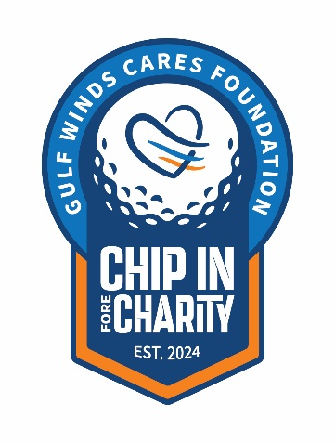
NEWS RELEASE
For Immediate Release
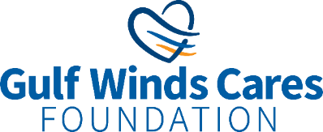
-------------------------------------------------------------------------
Gulf Winds Credit Union
For more information, contact:
Lauren Clark Public Relations Specialist
Office: 850-479-9601, x149 | Email
Lauren.Clark@gogulfwinds.com
------------------------------------------------------------------------
Gulf Winds Hosts First Charitable Golf Tournament
Raises over $33,000 to Support the Foundation’s Initiatives
Pensacola, Florida (May 4, 2024) – On Monday, April 22, the Gulf Winds Cares Foundation proudly hosted its inaugural Chip in Fore Charity Golf Tournament at Stonebrook Golf Course in Pace, FL. With the support of golf enthusiasts, sponsors, and donors, the event raised over $33,000 for the Foundation and its charitable activities.

The tournament brought the community together for a day of golfing, networking, and giving to support over 20 local non-profits, including the Council on Aging of West Florida, Big Brothers Big Sisters of Northwest Florida, Manna Food Pantries, and Junior Achievement of the Big Bend, amongst others.

27 teams competed in a classic four-player scramble featuring hole-in-one challenges and several putting games. Among the participants, Billy Burch, Michael Heller, Clay Mallard, and Louie Roberson claimed the first-place title, followed by Bobby Baker, Therran Gentry, Chuck Fox, and Derrick Williams in second place, and Jim Eanes, Jon Stead, Kelly Massey, and Doug Douglas in third.

Josh Newby, CEO and President of Council on Aging of West Florida, spoke at the event about the Foundation’s impact and said, “The Gulf Winds Cares Foundation has been there during tough times for our seniors, donating hundreds of thousands of dollars over the years. We couldn’t do what we do without the support of our partners and we are proud to benefit from Gulf Winds giving legacy.”

Gulf Winds extends its gratitude to its sponsors and donors, whose generous support made the event possible: Reedmark Advisors, Experian, Kurt Stenerson, Appleyard Duncan McCall, Tijuana Flats, Allied Solutions/Route 66, ALM First, Business Data Inc., Evergreen, Equifax, Helmsing Leach, Raymond James, Sorenson Van Leuven Law Firm, Syntropy Group, SWBC, World Ford Pensacola, and many more.

The 2025 Annual Chip in Fore Charity will be held next Spring. To donate to the Gulf Winds Cares Foundation please visit GoGulfWinds.com/Foundation.

About Gulf Winds:
Since 1954, Gulf Winds Credit Union has offered products and services that Move Members Forward. As a full-service financial organization, Gulf Winds provides 13 branch locations, digital banking, nationwide surcharge-free ATMs, and the support of more than 235 knowledgeable employees committed to delivering exceptional service. Gulf Winds is also renowned for its community involvement, founding the Gulf Winds Cares Foundation in January 2021 to formalize the longstanding charitable efforts of the organization. With a mission to create a sustainable funding source for community organizations that provide elder services, youth services, basic needs, and financial education, the Foundation can be depended on year after year. To learn more about Gulf Winds and the Foundation, please visit GoGulfWinds.com.
###

