PRESS RELEASE FOR IMMEDIATE RELEASE: May 29, 2024

MEDIA CONTACT:

Carla Keister
Tower Federal Credit Union
301-497-7000, ext. 7144
carla.keister@towerfcu.org

Tower Federal Credit Union Earns Great Place to Work® Certification—Six Years in a Row!

Tower has received recognition for the sixth consecutive year by the independent analysts at Great Place to Work®, an industry leader on quantifying employee experience.

[Laurel, Md. – May 29, 2024] For the sixth consecutive year, Tower Federal Credit Union has been named a “great workplace” by the independent analysts at Great Place to Work® (GPTW). Rick Stafford, Tower’s President and CEO, credits Tower’s exceptional team of employees and the credit union’s service-driven, people-oriented
culture as the reason for the recognition.

“Our Great Place to Work recognition is especially meaningful because it comes from our employees,” said Rick Stafford, Tower’s President & CEO. “It shows us how we measure up as a workplace against companies of all sizes, across all industries. We take the results of these surveys seriously, and, while no company big or small can claim perfection, we listen, make adjustments when we can, and always strive to make Tower the place our employees choose to be.”

Tower earned the GPTW credential based on extensive ratings provided by employees who participated in anonymous voluntary surveys about the credit union’s initiatives, leadership, and overall direction. Employees cited a welcoming work atmosphere, generous benefits package, the ability to take time off when needed, flexible schedules, and community give-back amongst the top reasons why Tower is a great place to work.

“Great Place to Work is the global authority on high-trust, high-performance workplace cultures,” Stafford said. “The company provides the benchmarks, framework and expertise to create, sustain, and recognize outstanding work cultures. I am thankful to those on our team who took the time to participate in the voluntary survey, and I am honored to lead such an outstanding group of people.”

Consistently, employees gave Tower high marks for the credit union’s philanthropic work environment and commitment to giving back to the local community, most notably through the TowerCares Foundation, which helps active military, Veterans, and children in need.

“Helping our military heroes and children in need in our community has always been an important part of Tower’s culture,” said Stafford. “Our employees are ardent supporters of TowerCares and its mission to help those who sacrifice every day to protect our freedoms.”

Tower offers competitive compensation and a comprehensive benefits package, including $0 out-of-pocket premium cost for Employee Only PPO and exceptionally low premiums for all other PPO coverage levels. The credit union will host an in-person Job Fair at their Laurel, Md. headquarters on July 2, 2024, from 2:00 pm to 7:00 pm. To view current employment opportunities, visit Careers at towerfcu.org.

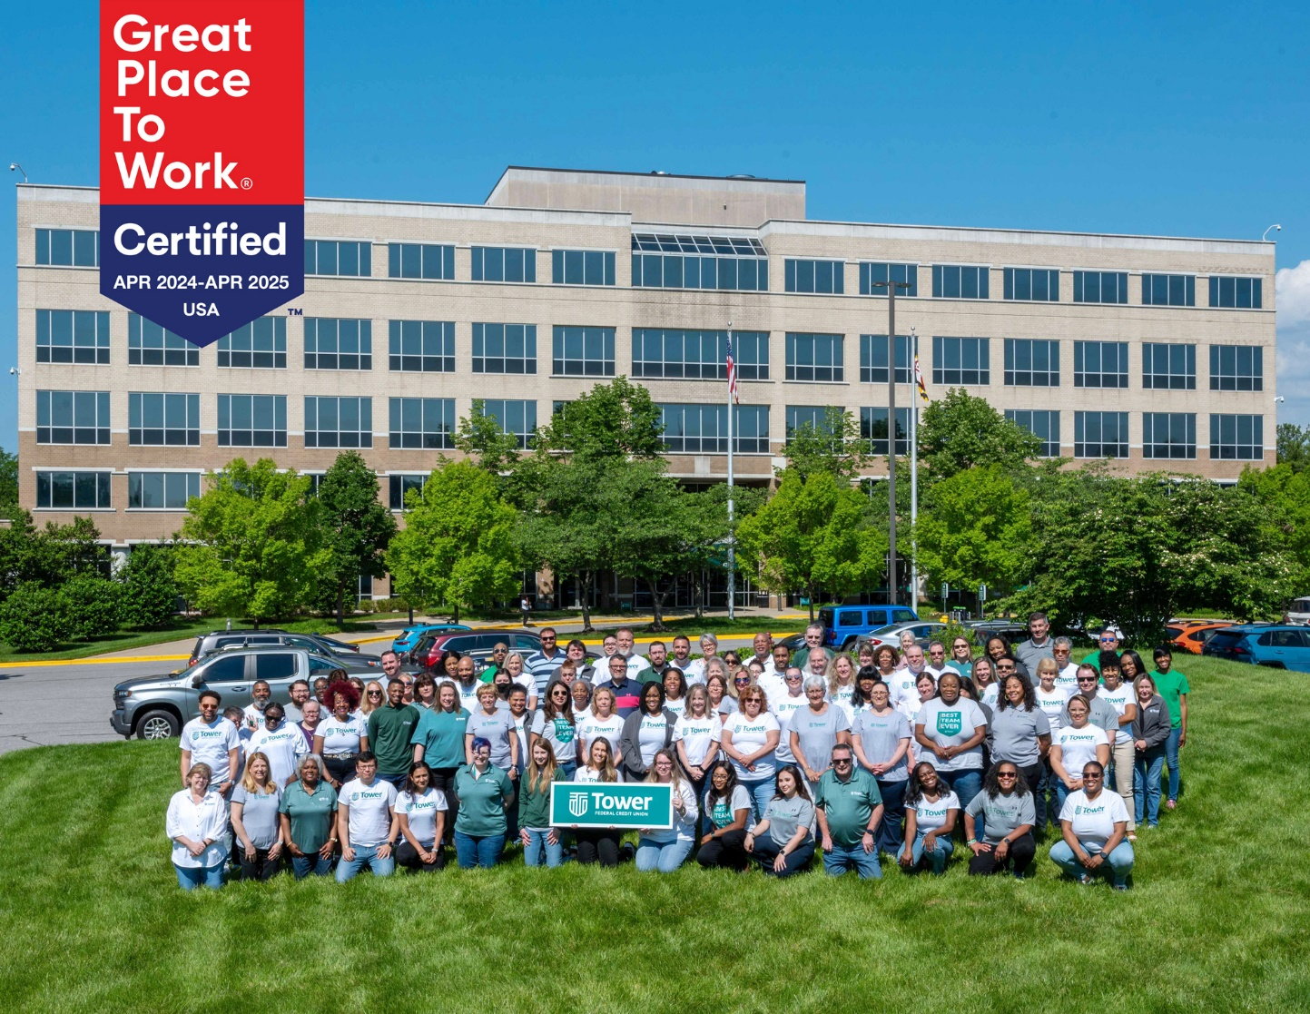
Photo Caption: Tower Federal Credit Union employees gather outside Tower’s Headquarters building in Laurel, Md. to celebrate the credit union’s recognition for the sixth year in a row as a “Great Place to Work” by the independent analysts at Great Place to Work®, an industry leader on quantifying employee experience. Tower will host an in-person Job Fair at their Laurel Headquarters on July 2, 2024 from 2 pm to 7 pm. To view current job openings, visit Careers at towerfcu.org. [Photo Credit: Michael Ciesielski]

About Tower Federal Credit Union
Tower Federal Credit Union is a member-owned, non-profit financial institution with headquarters in Laurel, MD. Established in 1953, Tower is one of the largest credit unions in Maryland with over $4.7 billion in assets. We provide a full array of financial products and services for our more than 221,000 members worldwide. We serve our local-area members with 12 branches in Anne Arundel, Baltimore, Howard, and Prince George’s counties and three branches at Fort Meade, as well as online services and digital banking at towerfcu.org.

