

**United Federal Credit Union – Press Release**

May 30, 2024

Contact: Matt Orlando

Phone: (888) 982-1400 ext. 1473

Email: [morlando@UnitedFCU.com](mailto:morlando@UnitedFCU.com)

United Federal Credit Union, 150 Hilltop Road, St. Joseph, Michigan, 49085

**United Federal Credit Union Names New Mortgage Advisor in Mishawaka**

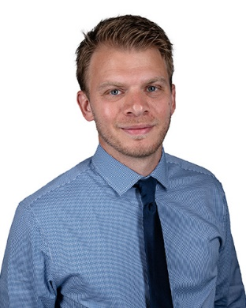

*Justin Prawat, Mortgage Advisor, Mishawaka*

**MISHAWAKA, Ind. –** United Federal Credit Union (United) is pleased to announce the appointment of Justin Prawat to Mortgage Advisor in Mishawaka. Prawat is based at United’s Edison Lakes branch located at 4840 N. Main Street in Mishawaka.

Prawat will use his expertise to provide a quality real estate lending experience through financial counseling and product awareness to credit union members regarding their real estate financing needs and generate investment quality mortgage loans.

Justin Prawat has over 11-years’ experience in the financial industry holding various roles including Mortgage Loan Officer, Branch Service Representative, and Call Center Lending Agent. He pairs his industry knowledge with a passion to help people find the right mortgage option for their new home. Most recently, Prawat worked as a Mortgage Loan Officer at Notre Dame Federal Credit Union.

**____________**

**About United**

United Federal Credit Union has served its Members since 1949 by helping them to build a sound financial future. United consists of more than 194,000 Member/owners worldwide and manages assets in excess of $4 billion. Its corporate office and main branch are in St. Joseph, Mich., with additional branches in Arkansas, Indiana, Michigan, Nevada, North Carolina, Ohio, and Pennsylvania. Federally insured by NCUA. Equal opportunity lender. Equal housing lender. For more information visit [UnitedFCU.com](http://www.unitedfcu.com)

# # #