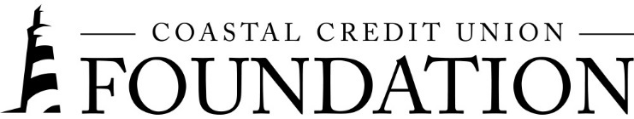
NEWS RELEASE
Contact: Joe Mecca
VP, Communication / Spokesperson
919-420-8044 / jmecca@coastal24.com
FINAL: For Immediate Release

Coastal Credit Union Foundation Awards $438k in Grants

RALEIGH, N.C. (June 18, 2024) – The Coastal Credit Union Foundation has awarded $438,000 to 16 nonprofits in North Carolina during its Q2 2024 grant cycle. The sixteen grants given to these nonprofits will improve access to resources and support financial well-being programs throughout our local communities.

Grants include $100,000 to the United Way of the Greater Triangle, which will continue our partnership in the Band Together fundraiser for a third year.

The Foundation’s other recent grantees include:

Access to Resources
- Chatham Arts Council
- Childrens Miracle Network Hospitals
- Connecting Community
- Paddling for Pennies
- Raleigh Music Collective
- Ripe for Revival
- Urban Ministries of Durham
- Youth Ambassadors of Service

Affordable Housing
- The Green Chair Project
- The Marian Cheek Jackson Center
- NC Coalition to End Homelessness
- NC Housing Coalition
Financial Well-Being
- Boys & Girls Clubs of Durham and Orange Counties
- Nobility Inc
- StepUp Ministry

“The Coastal Credit Union Foundation is a reflection of our dedication to concern for community, as stated in our Cooperative Principles.,” said Emily Nail, executive director of the Foundation. “We are committed to supporting our members, workforce, and voluntary contributors to facilitate the optimum financial health and prosperity while increasing the impact of our nonprofit grantees!”

About the Coastal Credit Union Foundation
The Coastal Credit Union Foundation is a 501(c)(3) nonprofit and a separate entity from the credit union. The mission of the Coastal Credit Union Foundation is to enrich the lives of Coastal members and their communities by providing financial support to 501(c)(3) organizations, particularly in the 16-county market of Central North Carolina. Learn more at www.coastal24.com/foundation/.

###

