PRESS RELEASE FOR IMMEDIATE RELEASE: June 20, 2024

MEDIA CONTACT:

Carla Keister
301-497-7000, ext. 7144
carla.keister@towerfcu.org

Tower Federal Credit Union Welcomes Susan Ralston as New Chief Operating Officer

Susan Ralston, Tower’s new Chief Operating Officer (COO), brings to the credit union over 30 years of leadership experience in the banking and financial industry, with a strong background in fraud prevention and mitigation.

[June 20, 2024 - Laurel, MD] Tower Federal Credit Union, one of the largest credit unions in Maryland, is pleased to announce the hiring of Susan Ralston as new Chief Operating Officer (COO). Ralston brings to Tower over 30 years of leadership experience in the banking and financial industry, and as COO, will oversee Tower’s Deposit Operations, Debit Card Operations, Fraud, Bank Secrecy Act Compliance, Business Continuity, and Facilities & Administrative Services department teams.

“We are happy to welcome Susan as the newest member of our senior management team,” said Rick Stafford, Tower’s President and CEO. “She brings to Tower over three decades of leadership experience in the banking industry, and a wealth of knowledge in areas key to our current and future strategies. She has extensive experience in the rapidly changing world of fraud prevention and mitigation that will serve to reinforce and strengthen our team and help protect our members.”

Before joining Tower, Ralston was Executive Vice President and COO for Old Point National Bank. She also previously served as COO/Senior VP for the Virginia Division of Dollar Bank, and as President and CEO for Bank @lantec prior to their acquisition by Dollar Bank.

“I am thrilled to join Tower as their new COO,” she said. “My goal is to enhance our operating efficiency while continuing to foster the credit union’s culture of innovation and teamwork. Together, we will continue to provide exceptional service and value to our members, ensuring their financial well-being and our organization’s growth.”

Recently, Ralston received an award from Virginia Business Magazine for 2023 Women in Leadership. She has also received Washington and Jefferson College’s Cleveland Waltersdorf Award for Innovative Leadership, and a Women in Business Achievement Award from Inside Business.

She earned her Bachelor’s Degree in Business Administration from Washington and Jefferson College, and Master’s Degree in Business Administration from Old Dominion University. Ralston earned her professional coaching certification from Duquesne University’s Palumbo-Donahue School of Business and associate certified coach credential from the International Coaching Federation.

To learn more about Tower, visit towerfcu.org.
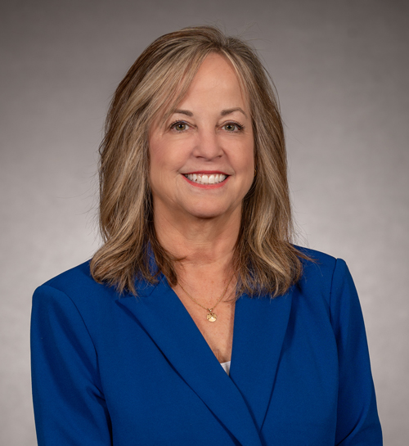

Pictured: Susan Ralston is the new Chief Operating Officer for Tower
Federal Credit Union, one of the largest credit unions in Maryland.

###

About Tower Federal Credit Union
Tower Federal Credit Union is a member-owned, non-profit financial institution with headquarters in Laurel, MD. Established in 1953, Tower is one the largest credit unions in Maryland with over $4.7 billion in assets. We provide a full array of financial products and services and serve more than 221,000 members worldwide. Tower serves its local-area members with 12 branches in Anne Arundel, Baltimore, Howard, and Prince George’s counties and four branches at Fort Meade, as well as online services and mobile banking at towerfcu.org.

