

**United Federal Credit Union – Press Release**

June 26, 2024

Contact: Matt Orlando

Phone: (888) 982-1400 ext. 1473

Email: [morlando@UnitedFCU.com](mailto:morlando@UnitedFCU.com)

United Federal Credit Union, 150 Hilltop Road, St. Joseph, Michigan, 49085

**United Federal Credit Union Names New Mortgage Advisor in Springdale**

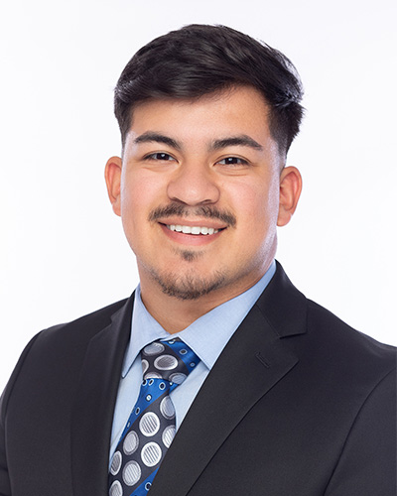

*Kevin Lopez, Mortgage Advisor, Springdale*

**SPRINGDALE, Ark. –** United Federal Credit Union (United) is pleased to announce the promotion of Kevin Lopez to Mortgage Advisor in Springdale. Lopez is based at United’s South Thompson branch located at 1910 S. Thompson Street in Springdale.

Lopez will use his expertise to provide a quality real estate lending experience through financial counseling and product awareness to credit union members regarding their real estate financing needs and generate investment quality mortgage loans.

Kevin Lopez began his career in the financial industry as a Teller over 5 years ago at Truity Federal Credit Union, which became United after the acquisition in 2021. He pairs his industry knowledge with a passion to help people find the right mortgage option for their new home. Most recently, Lopez worked as a Teller at United’s South Thompson Branch.

**____________**

**About United**

United Federal Credit Union has served its Members since 1949 by helping them to build a sound financial future. United consists of more than 194,000 Member/owners worldwide and manages assets in excess of $4 billion. Its corporate office and main branch are in St. Joseph, Mich., with additional branches in Arkansas, Indiana, Michigan, Nevada, North Carolina, Ohio, and Pennsylvania. Federally insured by NCUA. Equal opportunity lender. Equal housing lender. For more information visit [UnitedFCU.com](http://www.unitedfcu.com)

# # #