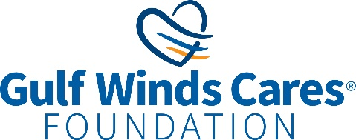**NEWS RELEASE**

For Immediate Release

-------------------------------------------------------------------------

**Gulf Winds Credit Union**

For more information, contact:

**Lauren Clark, Public Relations Specialist**Office: 850-479-9601, x149 | Email: [Lauren.Clark@gogulfwinds.com](mailto:Lauren.Clark@gogulfwinds.com)   
-------------------------------------------------------------------------

**Gulf Winds Cares Foundation Donates to Alabama Nonprofits**

**Pensacola, Florida (July 8, 2024) —** Recently, the Gulf Winds Cares Foundation made donations to the Youth Men’s Christian Associations, better known as the YMCA, of Brewton and Monroeville, Alabama. The organizations each received $2,000 to support their ongoing mission of providing a safe, engaging, and supportive environment for kids to learn, grow, and thrive, a pursuit Gulf Winds deeply supports.

YMCAs play a vital role in shaping our youth's lives and futures. They offer families affordable after-school programs, provide peace of mind to working parents, and empower young people to realize their potential. Donations ease financial burdens for parents, ensuring a safe and affordable haven for their children without worry or stress.

“The Brewton Area YMCA is fortunate to be able to partner with the Gulf Winds Cares Foundation to serve the youth in our community,” said Rob Kirkland, CEO of the Brewton Area YMCA. “Through this type of support, we can serve children who otherwise might not have the opportunity to participate in many programs.”

The Brewton and Monroeville area YMCAs also host summer camp programs for youth, allowing children to learn new skills while focusing on educational activities and making new friends. “We believe that every child deserves the chance to have a memorable and enriching summer and these scholarships ensure that children from all economic backgrounds have the opportunity to participate,” said Ricky Powell, CEO of the Monroeville Area YMCA. “We are deeply grateful for this partnership and look forward to a summer full of fun, learning, and growth.”

To join the Gulf Winds Cares Foundation in supporting the YMCA, visit YMCA.org.

XXX

**About the Gulf Winds Cares Foundation:**

Since 1954, Gulf Winds Credit Union has offered products and services that Move Members Forward. As a full-service financial organization, Gulf Winds provides 13 branch locations, digital banking, nationwide surcharge-free ATMs, and the support of more than 235 knowledgeable employees committed to delivering exceptional service. Gulf Winds is also renowned for its community involvement, founding the Gulf Winds Cares Foundation in January 2021 to formalize the longstanding charitable efforts of the organization. With a mission to create a sustainable funding source for community organizations that provide elder services, youth services, basic needs, and financial education, the Foundation can be depended on year after year. To learn more about Gulf Winds and the Foundation, please visit GoGulfWinds.com.