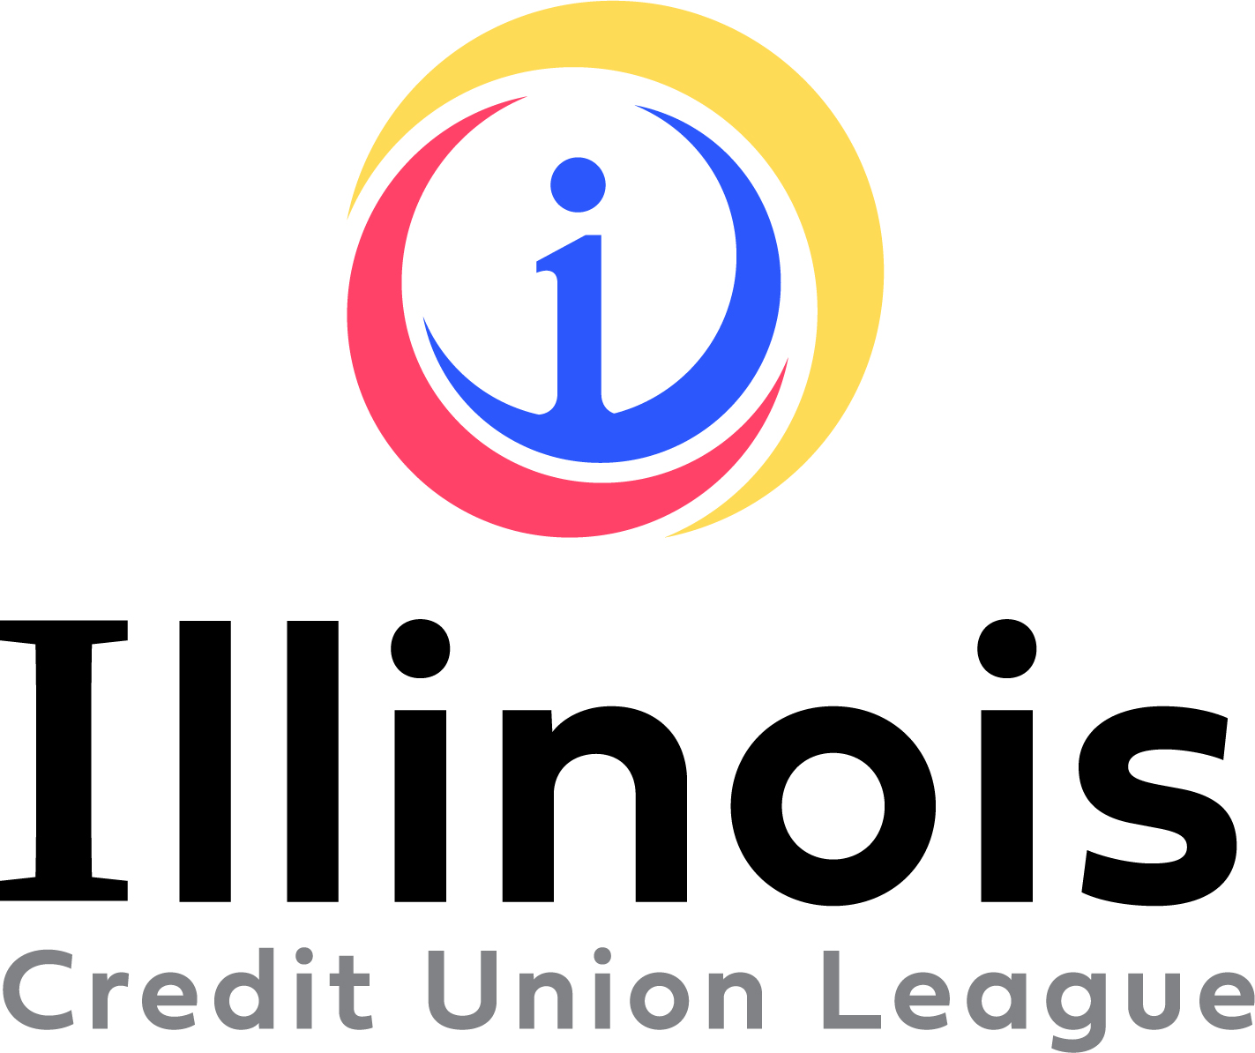
FOR IMMEDIATE RELEASE

Media Contact
Melissa Vidito
Illinois Credit Union System
630-637-3965
melissa.vidito@envisant.com

Illinois Credit Union League Announces 2023 Award Winners

Naperville, July 22, 2024 - The Illinois Credit Union League (ICUL) is thrilled to announce the recipients of its prestigious 2024 awards program. These awards recognize exceptional leadership, dedication, and innovation within the Illinois credit union movement.
The 2024 ICUL Award winners are:
- Small Credit Union Award
Deborah Fears, Chicago Post Office Employee Credit Union
This award honors the outstanding accomplishments of credit unions with assets under $50 million.
- Hall of Fame Lifetime Achievement Award
Charla Buchanan, Citizens Equity First Credit Union (CEFCU)
Charles Peterson, 74th Street Depot Federal Credit Union
This award recognizes an individual who has made a significant and lasting impact on the credit union movement in Illinois and potentially at the national level.
- Hall of Fame Leadership Achievement
Greg Anderson, University of Illinois Community Credit Union
This award honors an individual with a distinguished career demonstrating exceptional commitment to the credit union philosophy.
- Spirit of Service Volunteer of the Year
Betty Richardson, South Side Community Federal Credit Union
Cinda Klickna, Illinois Educators Credit Union
This award celebrates a dedicated volunteer whose exceptional contributions exemplify the credit union spirit of “people helping people.”
- Spirit of Service Employee of the Year
Kim Morris, Illinois Community Credit Union
This award recognizes a credit union employee who consistently goes above and beyond to serve members and exemplifies the credit union philosophy.
The winners will be formally recognized during the Celebration Lunch at the 94th Annual ICUL Convention on Friday, October 4, 2024, at the Sheraton Grand Chicago Riverwalk. “We’re incredibly proud of this year’s ICUL Award winners,” said Tom Kane, President/CEO of the Illinois Credit Union League. “These individuals have shown incredible leadership and dedication to their members and communities. It is an honor to watch them grow and contribute significantly throughout their careers in the credit union movement.”

###

About the Illinois Credit Union League
The Illinois Credit Union League is the primary trade association for more than 200 state and federal credit unions in Illinois. It focuses on providing legislative and regulatory advocacy, compliance assistance and information, and a wide range of educational and training services to those credit unions, who serve about 3.4 million members. More information can be found at www.icul.com.

(800) 942-7124
(630) 983-3400
(630) 983-4284 Fax
www.ilcu.com
Springfield Branch
225 S. College Ave., Suite 200
Springfield, IL 62704
(217) 744-1800
1807 W. Diehl Rd.
P.O. Box 3107
Naperville, Illinois
60566-7107

