FOR IMMEDIATE RELEASE

CONTACT:
Heather Ristow, CCUE
Senior Vice President / Chief Experience Officer
Corporate Central Credit Union
(414) 373-2108

Corporate Central Pioneers the Future of Payments with Superior ACH Solutions and Beastro Platform Integration

MILWAUKEE, WI – July 9, 2024 – Corporate Central is revolutionizing the payments landscape with cutting-edge ACH Solutions and its innovative Beastro platform, setting a new standard for the industry. The corporate credit union’s direct connection with the Federal Reserve and the integration capabilities of Beastro empowers credit unions to deliver seamless, efficient, and secure transactions to their members.

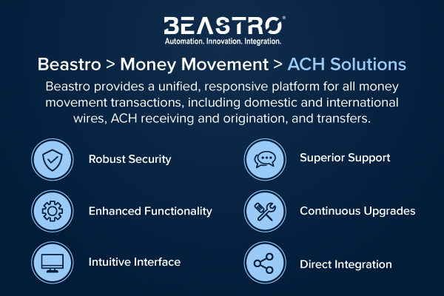

In 2024, Corporate Central launched Beastro > Money Movement > ACH Solutions, a platform designed to offer frictionless ACH transactions with enhanced functionality, robust security, and an intuitive interface. Beastro provides a unified, responsive platform for all money movement transactions, including not only ACH receiving and origination, but also domestic and international wires, and both internal account and member-to-member transfers.

"Our direct integration with the Federal Reserve eliminates points of failure and redundant vendors," stated Chris Felton, President/CEO. "This ensures unparalleled reliability and efficiency in all our ACH services. Beastro enables credit unions to receive incoming files and perform ACH origination seamlessly. With access to same-day ACH functionality, business direct ACH options, and international ACH services, we are providing a comprehensive solution all in one place."

"Our technology ownership allows us to continuously upgrade and incorporate cutting-edge security and industry best practices," noted Gregg Tushaus, SVP/Chief Technology and Strategy Officer. "Daily reporting tools provide robust recordkeeping, effortless cash management, and superior risk management. Plus, frequent enhancements based on member feedback keep us ahead of the curve.”

“One of the standout features of Beastro is our exceptional support," emphasized Felton. "Since we built and developed the software in-house, there are no layers of support. Our members connect directly with our dedicated Member Services team, ensuring they receive the guidance they need whenever they desire it."

ACH Analytics – Pilot Program
Corporate Central is looking for a small group of credit unions to pilot an ACH Analytics service. This service provides valuable insights into ACH transactions, tailored to the specific needs of each credit union. Reports can be generated based on various criteria, including transaction types, specific routing numbers, death notifications, IATs, and more. These reports are delivered securely from the Federal Reserve, ensuring that credit unions have the information they need to make informed decisions. Credit unions interested in this service should contact Corporate Central at memberservices@corpcu.com.

Corporate Central is dedicated to innovation and delivering top-tier ACH services that are essential to their member credit union's operations. Their commitment to excellence is reflected in their continuous development of the Beastro platform, integrating member feedback and industry best practices to provide the best possible experience.

Learn more about the Money Movement ACH Beastro module. For an introduction to ACH basics, read Corporate Central’s ACH FAQ blog post.

Helping Members to be Wildly Successful

About Corporate Central Credit Union
Corporate Central Credit Union is a federally insured financial cooperative built on the values of commitment to service, fiscal responsibility, and respect for the individual. We cultivate a culture of respect, ethics, teamwork, and innovation. We are "Helping Members to be Wildly Successful" by delivering industry knowledge and expertise to help credit unions achieve their strategic objectives and compete in today’s evolving financial services industry. We are motivated to passionately serve our members and strive to learn, create, and innovate daily. Please visit corpcu.com to learn more, and follow us on Facebook, LinkedIn, Twitter, and YouTube.

