FOR IMMEDIATE RELEASE

CONTACT:

Alison Barksdale, PR & Content Manager

817-219-6281

[alison.barksdale@cudirect.com](mailto:alison.barksdale@cudirect.com)

[www.origence.com](http://www.origence.com)

**ORIGENCE ANNOUNCES NEW ASSOCIATE BOARD MEMBERS**

**Irvine, CA, August 1, 2024** – [Origence](https://origence.com/solutions/credit-union-solutions/outsourced-loan-processing/), the leading lending technology solutions provider for credit unions, announced the appointment of three new associate Board of Directors effective August 1, 2024.

The new associate Board of Directors are:

* **Linda Armyn, president and CEO of Bethpage Federal Credit Union**

located in Bethpage, NY (473,707 members, more than $12 billion in assets)

Bethpage Federal Credit Union selected Linda Armyn as President and CEO in 2023 after serving the credit union for 22 years, most recently as Chief Strategy and Marketing Officer. Armyn has a Master’s in Corporate Communications & Organizational Design from Northeastern University and a Bachelor of Science in English Language and Literature from the University of Maryland.

* **April Clobes, president and CEO of Michigan State University Federal Credit Union**

located in East Lansing, MI (358,797 members, more than $7.8 billion in assets)

Clobes has been the President and CEO of Michigan State University Federal Credit Union since 2015. She joined MSUFCU in 1996 and moved through the organization from a marketing specialist to management and executive positions. Clobes has a Bachelor of Arts in Marketing from Michigan State University and a Master of Business Administration from Western Michigan University.

* **Chad Graves, president and CEO of Ent Credit Union**

located in Colorado Springs, CO (538,328 members, more than $9.8 billion in assets)

Graves became President and CEO of Ent Credit Union in 2017 after joining the credit union in 1999 and serving in various management and executive positions. Graves has a Bachelor of Science in Management Information Systems from the University of Idaho and is a Certified Chief Executive (CCE) and Certified Credit Union Executive Manager (CEM) from Credit Union Executive Society.

Also serving on the Board of Directors:

* Erin Mendez, president and CEO of Patelco Credit Union
* Bob McKay, president and CEO of Together Credit Union
* Kim Sponem president and CEO of Summit Credit Union
* Bill Cheney president and CEO of SchoolsFirst Federal Credit Union
* Don Clark president and CEO of Sound Credit Union
* Ron Neumann president and CEO of Oregon Community Credit Union
* Sandra Sagehorn-Elliott president and CEO of Vantage West Credit Union
* Thayne Shaffer president and CEO of America First Credit Union
* Steph Sherrodd president and CEO of Sandia Laboratory Federal Credit Union
* Karen Roch president and CEO of Credit Union of the West

## “We are thrilled to welcome our new associate board members to our organization,” said Tony Boutelle, president and CEO of Origence. “Their diverse credit union, lending, and CUSO expertise will be invaluable as we continue to drive innovation and growth. We look forward to their contributions and are confident that their involvement will help us to set the strategic direction of the company and further our mission to serve our credit unions, credit union members, and dealerships.”

“We are honored to welcome Linda Armyn, April Clobes, and Chad Graves to our Board of Directors. Their proven leadership and deep commitment to the credit union industry bring a wealth of knowledge and perspective that will be crucial as we navigate the evolving financial landscape,” said Erin Mendez, board chairman of Origence and president and CEO of Patelco Credit Union. “With their guidance and collaboration, we are poised to continue driving forward to best serve credit unions and their members with innovative technology solutions.”

## **About Origence**

[Origence](https://origence.com/) provides the lending technology solutions credit unions need to advance their total origination experience. We were established in 1994 as a credit union service organization (CUSO) and have helped credit unions process more than 88 million applications for $551 billion in funded loans. Our solutions include indirect lending, loan and account origination, auto shopping, marketing automation, lending operations, and more. Origence was named the 2023 CUSO of the year by NACUSO. Learn more at www.origence.com and follow us on [Twitter](https://twitter.com/origencecompany) and [LinkedIn](https://www.linkedin.com/company/origencecompany/).

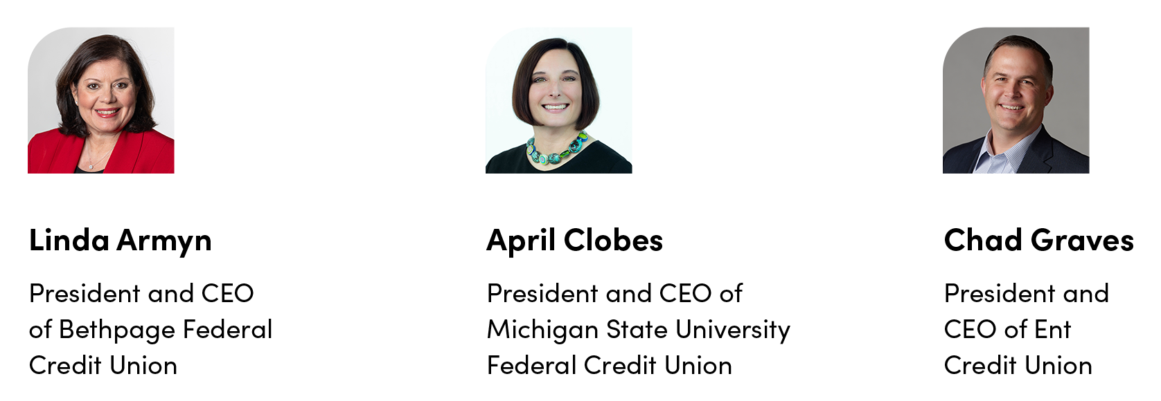

**PHOTO CAPTIONS:** Linda Armyn, president and CEO of Bethpage FCU, April Clobes, president and CEO of Michigan State University FCU, and Chad Graves, president and CEO of Ent CU are the newest associate members of the Origence Board of Directors this year.

###