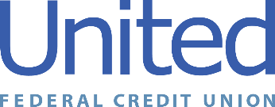

**United Federal Credit Union – Press Release**

September 11, 2024

Contact: Matt Orlando

Phone: (888) 982-1400 ext. 1473

Email: morlando@UnitedFCU.com

United Federal Credit Union, 150 Hilltop Road, St. Joseph, MI 49085

**United Federal Credit Union Celebrates Allentown Branches, New Regional Market with Ribbon Cutting Ceremony**

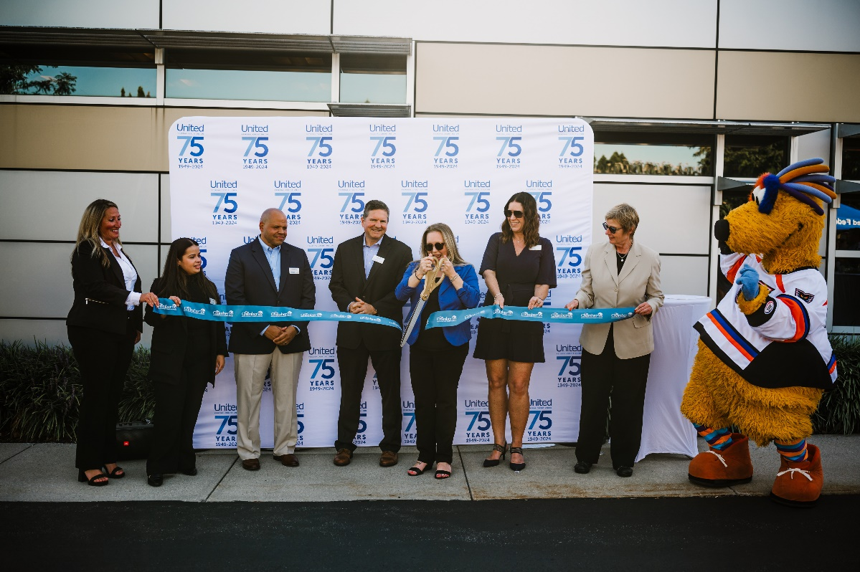

*United Federal Credit Union cuts the ribbon at its   
Allentown branch on Hamilton Blvd to celebrate successful merger.*

**ALLENTOWN, Penn. –** United Federal Credit Union (United) celebrated its newest region in Allentown, Pennsylvania with a ribbon cutting ceremony on Tuesday, September 10. United entered the Lehigh Valley market following a merger with GOLD Credit Union on April 1, 2024, followed by a successful system conversion of the credit unions on August 1. Tuesday’s event solidified United’s commitment to its Pennsylvania employees, newest members, and the Lehigh Valley community.

“United is thrilled to bring our innovative financial tools and solutions to the Pennsylvania market,” said Meredith Williams, United Regional Vice President. “The Lehigh Valley is a great match to us in terms of future growth and opportunity. Since the merger in April, this community has embraced us with open arms, and has been eager to take advantage of the vast number of products and services we offer. United looks forward to increasing our impact on our Pennsylvania Members and the community here.”

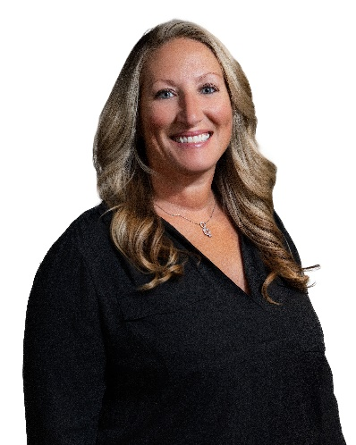

*Julie Huber, Relationship Development Manager—Allentown*

Julie Huber joined United in April 2024 as the Relationship Development Manager. She joined GOLD Credit Union in 2022 and has more than 20 years of financial and customer service experience. In her role, Huber oversees business development while promoting corporate member engagement, business and consumer membership and loan growth. Additionally, she is involved in the community and credit union events and activities to support the organization’s growth goals.

Huber serves on several community boards, including the Downtown Allentown Business Alliance, Ripple Community Inc, and Flint Hill Farm Agriculture Educational Center. She also serves on committees for a variety of local organizations including Habitat for Humanity, Lehigh Valley Chamber, and Family Promise Lehigh of Lehigh Valley. In her free time, Huber volunteers with the YWCA Allentown’s Perfect Fit for Working Women and the Allentown Rotary.

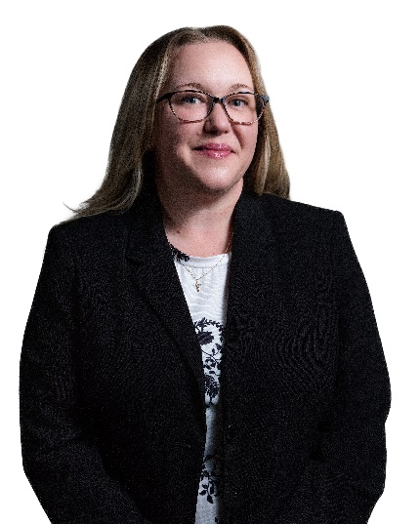

*Irene Emenheiser, Branch Manager—Downtown Allentown Branch*

Irene Emenheiser has been appointed to the position of Branch Manager at the Downtown Allentown location. She was with GOLD Credit Union since 2022.

As Branch Manager, Emenheiser is responsible for business development to promote corporate member engagement and positive public relations. She also maintains the performance of the branch, finding solutions through products and services, and providing leadership and supervision to staff.

Emenheiser has more than 22 years of experience in the financial industry. She has worked at both credit unions and banks and enjoys the personalized relationships of working with members at a credit union.

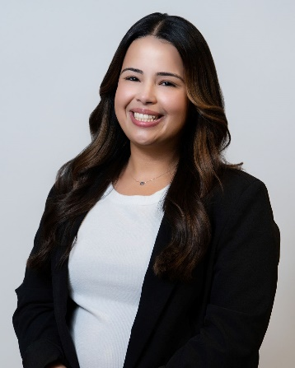

*Lydia Negron, Member Service Advisor—Allentown Branch*

Lydia Negron was promoted to Member Service Advisor at United’s Allentown location in 2024. She started with GOLD Credit Union in 2021.

In her role with United, Negron reinforces and builds member relationships and helps identify Members needs while making appropriate financial and lending decisions based on established guidelines.

She has eight years of financial and customer service experience. Negron is also active in the Lehigh Valley and has volunteered with Habitat for Humanity and Greater Valley YMCA in Bethlehem.

**____________**

**About United**

United Federal Credit Union has served its Members since 1949 by helping them to build a sound financial future. United consists of more than 194,000 Member/owners worldwide and manages assets in excess of $4 billion. Its corporate office and main branch are in St. Joseph, Mich., with additional branches in Arkansas, Indiana, Michigan, Nevada, North Carolina, Ohio, and Pennsylvania. Federally insured by NCUA. Equal opportunity lender. Equal housing lender. For more information visit [UnitedFCU.com](http://www.unitedfcu.com).

# # #