

**United Federal Credit Union – Press Release**

September 6, 2024

Contact: Matt Orlando

Phone: (888) 982-1473

Email: [morlando@UnitedFCU.com](mailto:morlando@UnitedFCU.com)

United Federal Credit Union, 150 Hilltop Road, St. Joseph, Michigan, 49085

**United Federal Credit Union Recognized   
as Global Workplace Leader**

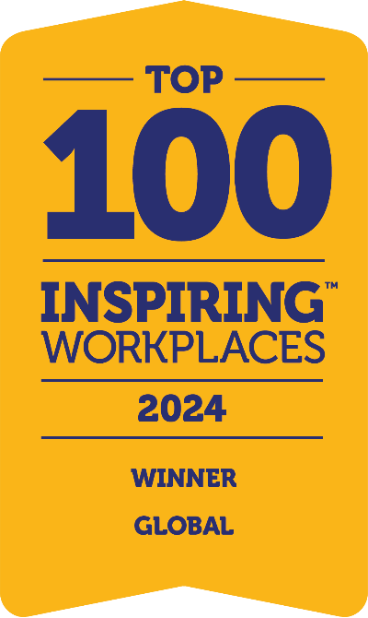

*United named to the 2024 Global Top 100 Inspiring Workplaces list.*

**ST. JOSEPH, Mich. –** Already recognized as one of the Top 100 Workplaces in North America, United Federal Credit Union (United) has earned a new distinction on the worldwide stage after being named one of the 2024 Global Top 100 Inspiring Workplaces by Inspiring Workplaces Group. The Top 100 list recognizes truly people-first organizations and has been compiled from the highest-scoring winners across Asia, Australasia, Europe, Latin America, Middle East & Africa, North America, and the UK & Ireland.

In each region, The Inspiring Workplaces Awards 2024 asks the same case study questions consisting of six key elements, including: purpose and culture, leadership, well-being, experience, employee voice, and inclusion.

Winners in each region were scored by an independent local expert judging panel, which were announced earlier in the year.

United has the distinction of being the only credit union selected in a group of companies that also includes Mastercard, PepsiCo, Staples, Squarespace, SurveyMonkey, Unilever, Verizon.

“The world now has a chance to learn what our members and community partners have known for decades, that Team United is made up of inspiring people,” said United President/CEO Terry O’Rourke. “It is a privilege to come to work every day and interact with smart, caring people who understand how to get the job done, but more importantly how to do so in a positive workplace that generates innovative ideas that are focused on making our members’ lives better.”

Matt Manners, Founder, The Inspiring Workplaces Group commented, “Congratulations to this year’s Top 100 Inspiring Workplaces. It’s the first time we have entries making this distinguished list from Asia and the Middle East & Africa. One clear message we can take from this news is that despite what else might be going on in the world, there is a clear and global desire to put people first being led by the private sector. Our mission is to change the world through the world of work, and recognizing these Inspiring Workplaces and their dedicated employees is a crucial step in that journey. Congratulations to all the winners.”

In addition to the 2024 Global Top 100 Inspiring Workplaces award, United has also been recognized as one of the Top 100 Workplaces in North America as well as one of the 2024 Best Credit Unions to Work For by American Banker.

**____________**

**About United**

United Federal Credit Union has served its Members since 1949 by helping them to build a sound financial future. United consists of more than 194,000 Member/owners worldwide and manages assets in excess of $4 billion. Its corporate office and main branch are in St. Joseph, Mich., with additional branches in Arkansas, Indiana, Michigan, Nevada, North Carolina, Ohio, and Pennsylvania. Federally insured by NCUA. Equal opportunity lender. Equal housing lender. For more information visit [UnitedFCU.com](http://www.unitedfcu.com)

**____________**

**About The Inspiring Workplaces Group – change the world**

[Inspiring Workplaces](https://www.inspiring-workplaces.com/) headquartered in the UK and operates in North America, Europe, Middle East, Africa, Latin America, Asia and Australasia. Inspiring Workplaces™ believes in recognizing and helping to shape the forward-thinking organizations of the future that put their people first. By shedding light on these innovative workplaces, Inspiring Workplaces helps to encourage positive change by providing a source of inspiration and education for others who seek it.

# # #