***FOR IMMEDIATE RELEASE***

*CONTACT:*

*Jesse Kohl, President*

*InterLutions, LLC*

*(414) 433-0174*

**CUSO’s CU-Save Program Delivers Major Cost Savings for Credit Unions**

**MILWAUKEE, WI – October 10, 2024** – InterLutions, a leading Credit Union Service Organization (CUSO), has once again delivered impressive savings for credit unions through its [*CU-Save*](https://www.interlutionscuso.com/CU-Save/Revenue-Enhancement/Overview?utm_source=CreditUnions.com&utm_medium=press_release&utm_campaign=CU-Save_Delivers_Again&utm_content=text_cu-save) program. Partnering with the industry-leading advisory firm SRM, InterLutions recently helped 34 credit unions save a combined $10 million by negotiating improved contracts with third-party vendors. Since its launch in 2017, *CU-Save* has helped over 80 credit unions across the country significantly reduce expenses and achieve more favorable agreements.

*CU-Save* is designed to help credit unions align pricing, increase incentives and income, and remove restrictive service requirements from their vendor contracts. According to Jesse Kohl, President of InterLutions, "This partnership was formed to boost the bottom-line performance of our credit union clients. About 90% of the credit unions we have worked with have discovered they were paying their vendors significantly more than the proven market value. Our unique blend of internal expertise and proprietary benchmarking tools has enabled many participating credit unions to achieve savings of six to seven figures, all while maintaining their preferred service partners and avoiding operational disruptions."

The *CU-Save* contract negotiation team uses an extensive archive of invoice data, payment analytics, and an industry benchmark software database to lower operational expenses. Through data-driven analysis, *CU-Save* has delivered significant cost reductions for credit unions of varying asset sizes, located in different states across the country. The CUSO reported recent success stories from three credit unions. Highlights from the report include:

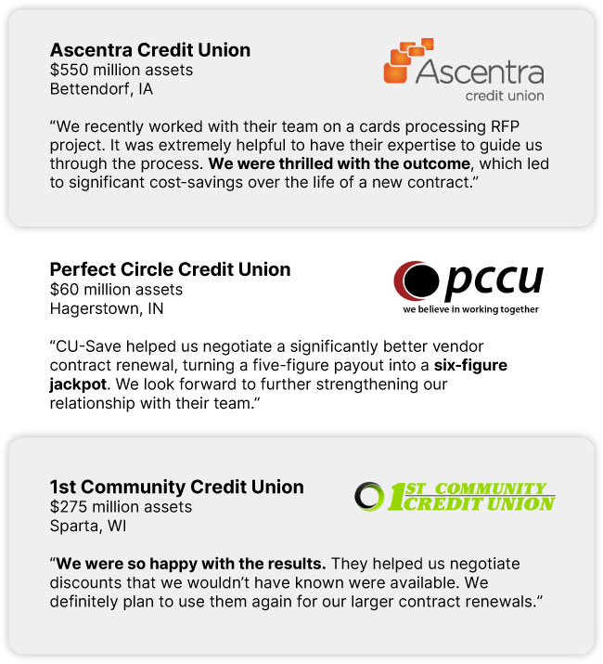

"We are proud of our subject matter experts who can be counted on to analyze a credit union's most expensive vendor agreements and cut out the unnecessary costs that are often built into contracts," continued Kohl. "Credit unions that partner with us can expect to see major improvements without any disruptions to service levels."

InterLutions encourages credit unions looking to reduce costs and explore new revenue streams to contact them for support. With *CU-Save*, credit unions can secure the contracts they deserve, at the prices they should be paying. To learn more about *CU-Save* and to view more credit union case studies and testimonials, visit [InterLutionsCUSO.com](https://www.interlutionscuso.com/?utm_source=CreditUnions.com&utm_medium=press_release&utm_campaign=CU-Save_Delivers_Again&utm_content=text_cu-save).

**About InterLutions**

*InterLutions is a credit union service organization (CUSO) focused on providing innovative business solutions to advance the credit union movement. At its core, InterLutions believes in the idea that collaboration within the credit union industry will provide more reliable and cost-efficient ways to keep credit unions strong and healthy. Please visit* [*InterLutionsCUSO.com*](https://www.interlutionscuso.com/?utm_source=CreditUnions.com&utm_medium=press_release&utm_campaign=CU-Save_Delivers_Again&utm_content=text_cu-save) *to learn more.*