



**Texas State University Student Wins Cruise**

**by Using Greater Texas|Aggieland Card**

**Austin, Texas, October 9, 2024** – Texas State University student Michael Valdez has a great vacation to look forward to, as the winner of the [Greater Texas|Aggieland Credit Union](http://www.gtfcu.org) Fuel Your Dreams Cruise Giveaway.

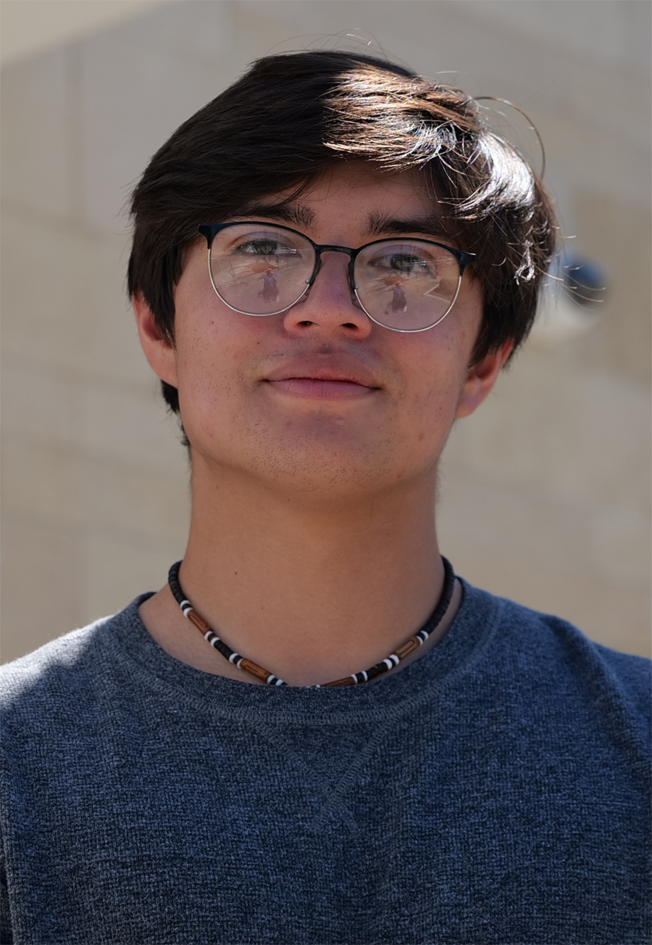

*Michael Valdez*

Valdez, a junior from Pflugerville studying criminal justice at Texas State, was chosen at random from among thousands of the credit union’s cardholders, each winning one entry into the contest each time they used their card at the gas pump from mid-May to the end of July.

This was the first time Greater Texas|Aggieland has given a cruise – a $2,000 voucher with Royal Caribbean Cruise Lines – as a prize, and the first time that buying gasoline with a debit or credit card earned a contest entry.

Valdez, who has been banking with Greater Texas Credit Union for eight years, hasn’t decided yet where he would like to go for his cruise. But in the midst of the inevitable stresses of studying and exams this school year, he has a great, relaxing experience to look forward to.

The credit union noted that the cruise giveaway contest generated more than 19,000 transactions, with a dollar value of $4.78 million. Valdez accounted for 20 of those transactions.

“We're always looking for ways to show appreciation to our members,” said Sidney Henderson, Vice President of Marketing at Greater Texas|Aggieland Credit Union. “Through this campaign, we were able to surprise one member with an incredible vacation experience, just for using our payment tools during everyday activities like filling up their gas tank.”

**About Greater Texas Credit Union**

[Greater Texas](http://www.gtfcu.org) Credit Union, founded in 1952, is a financial cooperative that emphasizes community stewardship, charitable giving, and employee volunteerism through its Greater Good initiative. Together with its subsidiary, Aggieland Credit Union – which serves the Brazos Valley – the credit union offers a wide variety of consumer-oriented banking services to its 85,000 members across the state of Texas. Greater Texas has locations in Austin, Houston, San Antonio, Bryan-College Station, Edinburg, and the Dallas-Ft. Worth market with assets of nearly $1 billion.

###