**FOR IMMEDIATE RELEASE**  
**Media Contact**  
Melissa Vidito  
Illinois Credit Union System  
630-637-3965  
[melissa.vidito@envisant.com](mailto:melissa.vidito@envisant.com)

**Illinois Credit Union League Celebrates Record-Breaking CU Kind Day 2024**

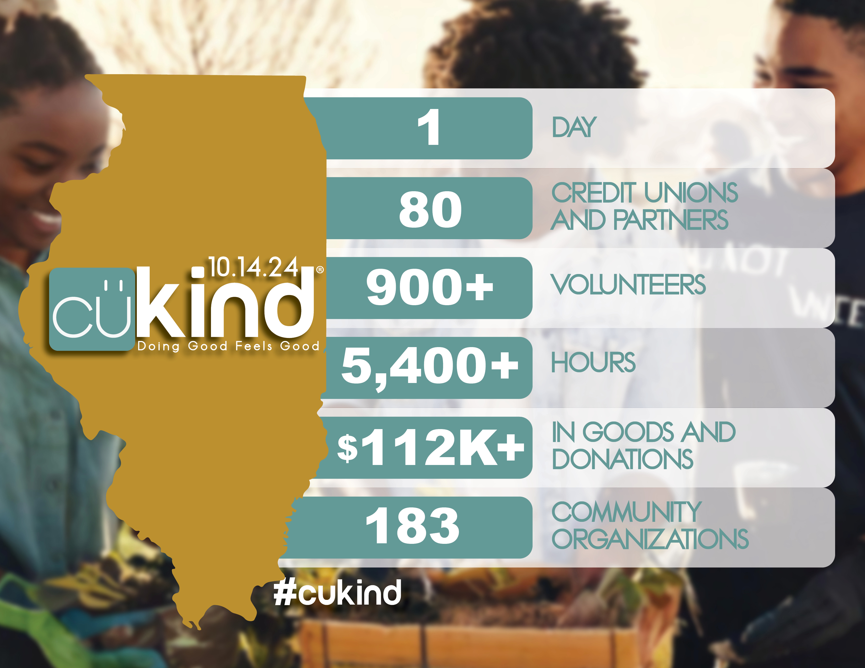**Naperville, Illinois (October 22, 2024)** – The Illinois Credit Union League (ICUL) is thrilled to announce another successful CU Kind Day®, its signature initiative dedicated to spreading kindness throughout the state. Held on October 14, the event saw an outstanding number of participants, solidifying its place as a cornerstone of credit union community engagement.  
  
**A Commitment to Giving Back**  
This year, 80 Illinois credit unions and partners joined forces with ICUL, demonstrating the unwavering commitment of the credit union movement to giving back. Over 900 dedicated volunteers generously donated their time, logging an impressive 5,400+ hours to support their local communities. Their efforts resulted in a record-breaking $112,000+ worth of goods and donations distributed among 183 community organizations across Illinois.

**Kindness in Action**

The spirit of CU Kind Day manifested in countless acts of generosity. Volunteers participated in a variety of activities, including:

* **Monetary donations** to support vital programs and services.
* **Food and clothing drives** to assist families in need.
* **Volunteer time** at local shelters, food banks, and community centers.
* **Donating school supplies** to ensure students have the resources they need to succeed.
* **Delivering care packages** to brighten the day of those facing hardship.

“We are humbled by the outpouring of support,” stated Staci Hering, ICUL’s Director of Culture and Engagement, and the driving force behind CU Kind Day. “Witnessing the dedication of our credit union volunteers in serving their communities is truly inspiring. These acts of kindness not only leave a lasting impact on those who receive them, but also embody the core credit union principle of ‘people helping people.’”

**Spreading Kindness Beyond State Lines**

CU Kind Day is not just an Illinois phenomenon. Inspired by the Minnesota Credit Union Network (MCUN) and ICUL’s initiatives, leagues and credit unions from across the country are embracing “kindness days” of their own. This year, credit unions in seven states, including Illinois, Michigan, Minnesota, Montana, New Jersey, Pennsylvania, and Wisconsin, joined forces to spread kindness in their communities.

###

**About the Illinois Credit Union League**

The Illinois Credit Union League is the primary trade association for more than 200 state and federal credit unions in Illinois. It focuses on providing legislative and regulatory advocacy, compliance assistance and information, and a wide range of educational and training services to those credit unions, who in turn serve approximately 3.4 million members. More information can be found at [www.icul.com](http://www.icul.com/).

(800) 942-7124

(630) 983-3400  
(630) 983-4284 Fax

www.ilcu.com

Springfield Branch

225 S. College Ave., Suite 200

Springfield, IL 62704

(217) 744-1800

1807 W. Diehl Rd.

P.O. Box 3107

Naperville, Illinois

60566-7107