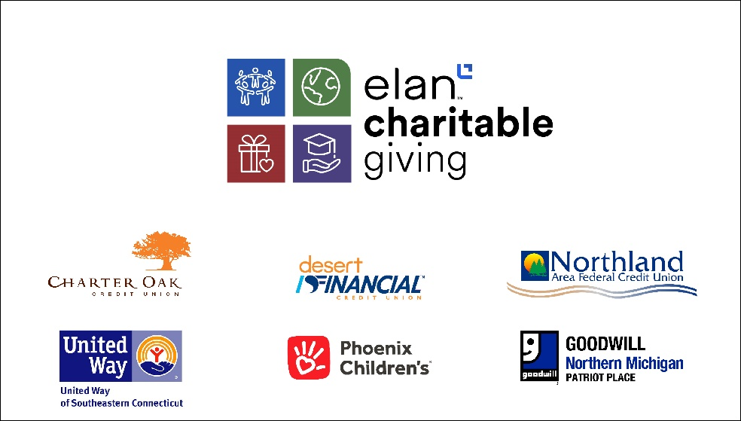

Making an Impact on International Credit Union Day
Elan donates $45,000 on behalf of credit union partners
FOR IMMEDIATE RELEASE  October 17, 2024 | Media contact:  Todd Deutsch  612.303.4148
(Minneapolis, MN) — To amplify the credit union movement and the value credit unions bring to their communities, Elan Credit Card (Elan) is celebrating International Credit Union Day with three, $15,000 donations on behalf of three credit union partners.
“Supporting the needs of our credit card partners extends beyond our business partnership, which is why we launched the Elan Charitable Giving program in 2022. To date, we have donated over $1.7 million, positively impacting more than 125 non-profits nationwide. We know how impactful credit unions are to the wellness of their members and we’re pleased to continue this program with donations to three new communities,” shared John Owens, Elan Credit Card General Manager.
Each credit union selected the organization based on the needs of their community. Areas of focus include food insecurity, medical care for children, and transitional housing and support for veterans.
The 2024 Elan credit union partners and selected beneficiaries include:
- Charter Oak Federal Credit Union (United Way of Southeastern Connecticut)
- Desert Financial Credit Union (Phoenix Children's Hospital)
- Northland Area Federal Credit Union (Goodwill Northern Michigan — Patriot Place)
A volunteer event will be scheduled at one of the organizations in the coming months. This opportunity will allow Elan and its credit union partner to volunteer together and further the impact of the donation.
Learn more about each organization, credit union, and the impact Elan is making in communities through its charitable giving initiative at www.elancharitablegiving.com.
About Elan Credit Card
Elan partners with credit unions through our turnkey credit card issuing solution, mortgage solutions, and all-in-one merchant processing platform, talech®. Our dedication to our partners, growth philosophy, and investment in technology has made us a leader in the industry since 1968. Our approach offers expertise while removing costs, reducing risks, and improving the cardmember experience. In a world of rapidly changing technology, increasing compliance burdens, and competing rewards programs, more have turned to Elan for innovative solutions for consumer and business accounts of all sizes. www.cupartnership.com

