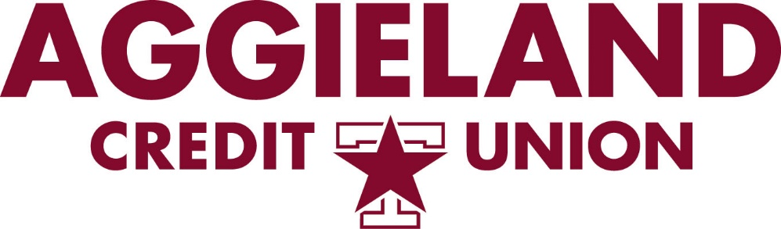



**Aggieland Credit Union Finances $53,000**

**in Texas A&M Student-run Entrepreneurial Ventures**

**Bryan-College Station, Texas, Nov. 19, 2024** – [Aggieland Credit Union](http://www.aggielandcu.org) funded $53,000 in short-term business loans for 12 student teams participating in the 2024 Texas A&M Mays Business School Integrated Business Experience (IBE).

Now in its ninth year, this is the first time IBE enterprises were able to use the intellectual property of Texas A&M University, including the logo, school emblem, mascot, slogans, buildings, landmarks, and more in their product design.

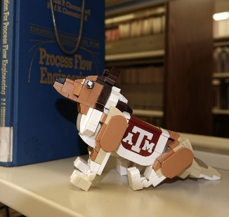

This allowed the students more creative license to develop products with greater appeal to Aggie fans. Some of the products that caught the attention of Aggieland Credit Union judges are [Build-a-Rev](https://build-a-rev.market.haus/), a LEGO brick model of Texas A&M’s mascot Reveille; [Tradition Trays](https://traditiontrays.market.haus/), a Reveille-shaped jewelry dish with her design imprinted onto it; and [Jig Saw ‘Em Off](https://jseopuzzles.market.haus/), a custom jigsaw puzzle of the beloved Aggie Tailgate painting by Benjamin Knox.

As the official credit union sponsor of Texas A&M University and the Mays Business School IBE program, Aggieland Credit Union worked with the Texas A&M office of Business Development to facilitate the use of Texas A&M logos by the students for the purpose of their IBE businesses.

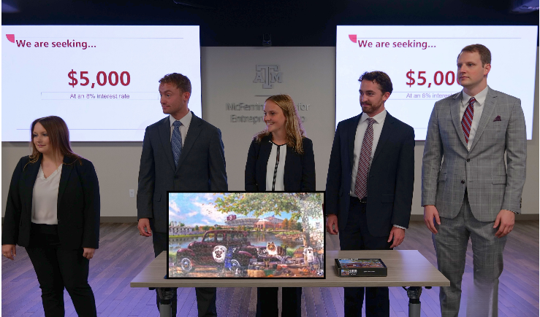“IBE is an experiential class that gives postgraduate students the ability to apply what they have learned in a real-life business scenario,” said Blake Petty, Executive Director of the McFerrin Center for Entrepreneurship at Texas A&M University and instructor for the IBE course. “It allows them to test their business acumen and work through every step required to start a business and successfully bring a product to market.”

Petty added, “This program teaches our students invaluable lessons so they are prepared to take on the risk and challenges of launching and operating a business.”

Judges from the credit union listened to *Shark Tank*-style pitches from each team vying to receive financing for their business from Aggieland Credit Union. The judges awarded funding from $3,500 to $5,000 based on their assessment of the business model, product concept, manufacturing, sales and marketing strategy, and other factors.

Products manufactured by the IBE enterprises will be available for sale through the end of the year. All profits from each business will be donated to select charities at the end of the class. The past eight class years, IBE businesses have donated more than $113,000 to local charities.

“What these students learn through this program will help many of them jumpstart their careers,” said Benjamin Teske, EVP and Chief Lending Officer at Greater Texas|Aggieland Credit Union. “We not only judge their funding pitches, we offer financial and marketing advice to help them strengthen their business models and products to ensure greater success.”

A profile of each 2024 IBE company can be viewed [here](https://www.market.haus/2024-ibe-stores).

**About Aggieland Credit Union**

[Aggieland Credit Union](http://aggielandcu.org/) was founded in 1985 by Aggies as a financial cooperative to support fellow Aggies and their families. The credit union is now a subsidiary of Austin-based Greater Texas Credit Union and emphasizes community stewardship, charitable giving, and employee volunteerism. Together with Greater Texas, Aggieland Credit Union offers a wide variety of consumer-oriented banking services to its 80,000 members across the state of Texas. The combined credit union has locations in Bryan-College Station, Austin, Houston, San Antonio, Edinburg, and the Dallas-Fort Worth market with assets of nearly $1 billion.

###