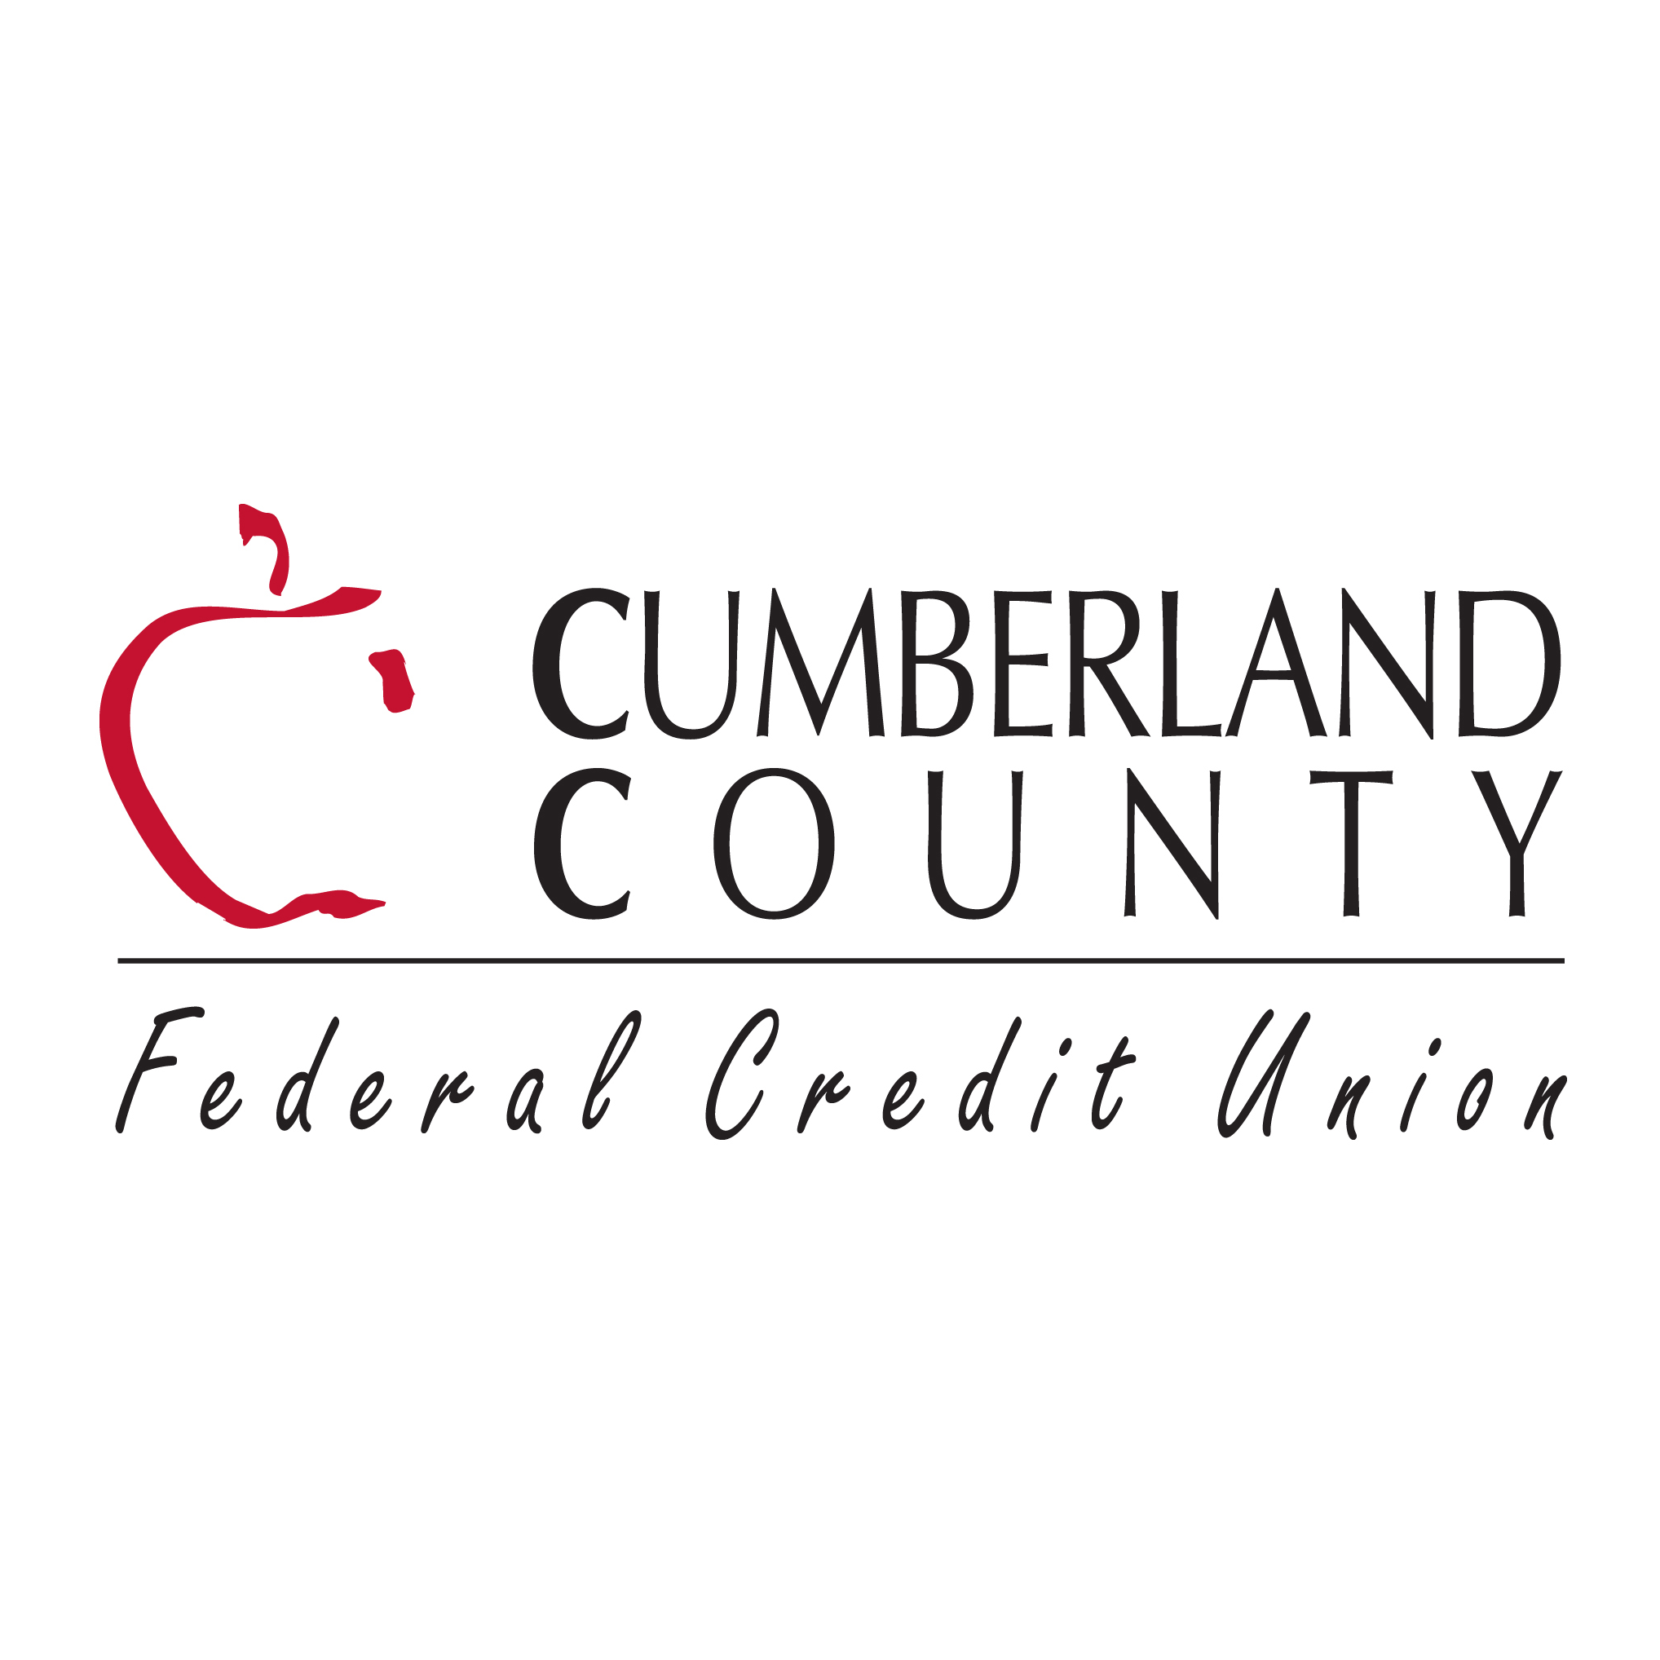Contact:  
Heather Cronin  
VP of Marketing  
Cumberland County FCU  
207-229-9603  
[hcronin@myccfcu.com](mailto:hcronin@myccfcu.com)

**FOR IMMEDIATE RELEASE**

**Cumberland County FCU Announces New Hire and Multiple Promotions**

Falmouth, ME (February 2025) – Cumberland County FCU (CCFCU) is pleased to announce the following team addition and employee promotions. Bethany Smith has been hired as the Vice President of Accounting; Amy Sithavady has been promoted to Vice President of HR and Compliance; Kimberly Parker has been promoted to Vice President of Service Center Operations; Abby Strout has been promoted to Cards Manager;Margie Heald has been promoted to Branch Service Manager in Yarmouth.

**Bethany Smith** joins CCFCU as the VP of Accounting, bringing years of experience in auditing financial institutions. Bethany will report to Chief Financial Officer Ryan Grund and bring her extensive experience to the CCFCU team.

**Amy Sithavady** has been promoted to the VP of HR & Compliance. She began her career nearly 16 years ago with our Service Team, then worked as a Collections Specialist, became our Internal Auditor, and then our AVP of Finance & Administration. She has excelled in all her roles and most recently she earned her SHRM-CP designation.

**Kimberly Parker** has been promoted to VP of Service Center Operations. Over the past 8 ½ years, Kim has consistently demonstrated exceptional leadership. She started as a Teller, and through hard work and dedication, she advanced from the branch to the contact center as a Cards Specialist, then Cards Manager, and most recently, as our AVP of Service Center Operations.

**Abby Strout** has been promoted to Cards Manager. She started 5 years ago as a teller, then moved up to the contact center as a Service Specialist II, then Card Specialist I and II. She’s become a real expert at catching fraud trends.

**Margie Heald** has been promoted to Branch Service Manager in Yarmouth. With six years of dedicated service to CCFCU, Margie has truly excelled in various roles, including Teller, SSI, and SSII. After taking a brief leave, she returned and quickly got back up to speed in the SSII role. Her wealth of knowledge and experience will be an asset to the Yarmouth team.

“In the past year, we’ve made many adjustments to ensure our continued growth and to strengthen our organization as a whole.” said Scott Harriman, President & CEO. “We are successful because each member of our team knows our membership and will continue to provide exceptional service to the communities we live in and serve.”

**About Cumberland County FCU**   
Established in 1954, Cumberland County Federal Credit Union (CCFCU) is the 8th largest credit union in Maine, locally operated and member-owned, and offering a full range of financial services. Headquartered in Falmouth, ME, CCFCU currently has a Contact Center and five branch locations – Portland, Westbrook, Gray, Windham and Yarmouth - and serves more than 22,000 members who live, work or study in Cumberland and York counties. For more information, visit [www.myccfcu.com](http://www.myccfcu.com) or like us on Facebook.

L to R (top row): Bethany Smith, VP of Accounting; Amy Sithavady, VP of HR & Compliance; Kimberly Parker, VP of Service Center Operations; (bottom row): Abby Strout, Cards Manager; Margie Heald, Yarmouth Branch Service Manager.

