

**United Federal Credit Union – Press Release**

February 25, 2025

Contact: Diana Wake

Phone: (269) 294-0163

Email: [dwake@UnitedFCU.com](mailto:dwake@UnitedFCU.com)

United Federal Credit Union, 150 Hilltop Road, St. Joseph, Michigan, 49085

**United Federal Credit Union Names New Mortgage Advisor in northern Michigan**

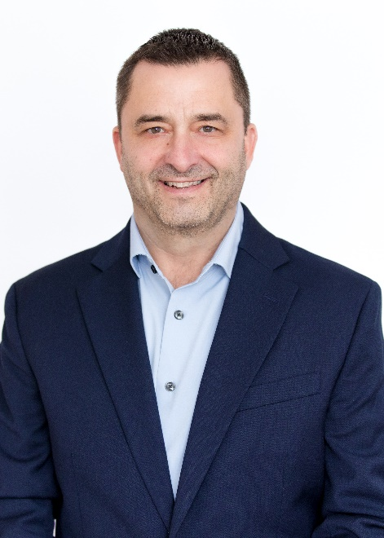

*Mike White, Mortgage Advisor, Traverse City*

**TRAVERSE CITY, Mich. –** United Federal Credit Union (United) is pleased to announce the appointment of Mike White to Mortgage Advisor serving the Traverse City area.

White will use his expertise to provide a quality real estate lending experience through financial counseling and product awareness to credit union members regarding their real estate financing needs and generate investment quality mortgage loans.

White brings more than 24 years of mortgage lending experience to his new role. He has spent the last four years focusing on mortgages in northern Michigan and was in a joint venture with Coldwell Banker Schmidt Realty in downtown Traverse City. He also was the team lead for a group of mortgage loan originators through 2023. Most recently, he was a Senior Mortgage Consultant with Coast One Mortgage.

In the Traverse City community, White actively supports youth sports. He has coached travel hockey for the past 8 years, youth soccer and baseball, and is currently the Head Coach of the Traverse City Central JV Lacrosse Team.

**____________**

**About United**

United Federal Credit Union has served its Members since 1949 by helping them to build a sound financial future. United consists of more than 194,000 Member/owners worldwide and manages assets in excess of $4 billion. Its corporate office and main branch are in St. Joseph, Mich., with additional branches in Arkansas, Indiana, Michigan, Nevada, North Carolina, Ohio, and Pennsylvania. Federally insured by NCUA. Equal opportunity lender. Equal housing lender. For more information visit [UnitedFCU.com](http://www.unitedfcu.com)