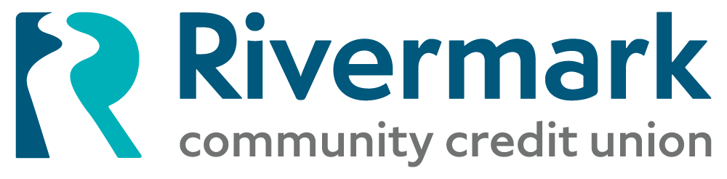

March 13, 2025

**For Immediate Release**

**Rivermark Donates $3 Million to**

**Rebuilding Together PNW**

PORTLAND, OR –The [Rivermark Community Fund](https://www.rivermarkcu.org/foundation) has directed a grant of $3 million through the support of the Federal Home Loan Bank of Des Moines (FHLB) to [Rebuilding Together PNW](http://www.rtpdx.org), a non-profit organization that works to improve the lives of low-income homeowners in the community by providing free home repairs and modifications.

Rebuilding Together PNW focuses on enhancing safety, accessibility, and comfort, allowing individuals and families to live in healthier, more stable environments. This targeted donation will provide new roofs for 86 homes, along with numerous HVAC replacements over the next three years, at no cost to homeowners.

"This grant to Rebuilding Together PNW is an investment in the entire community,” said Seth Schaefer, Rivermark Executive Vice President and Chief Impact Officer. “By supporting their work, Rivermark is doing our part to create safer, more accessible homes for families who need it most. It not only improves the individual lives of 86 local homeowners, but also strengthens the collective foundation of our neighborhoods.”

"I, along with the many others who made Rebuilding Together PNW what it is today, am humbled to be the recipient of this phenomenal award, said Stephanie Luyties, Executive Director at Rebuilding Together PNW. “We thank Rivermark Community Credit Union and the Federal Home Loan Bank of Des Moines for their generosity. We can now turn what were once growth opportunities into realities. With this grant, we can begin working on addressing critical unmet needs in our area. "

**About Rivermark Community Credit Union**

Rivermark Community Credit Union is a member-owned financial cooperative serving 180,000 members across Oregon and Southwest Washington. Established in February 1951 as Safeway Portland Employees Federal Credit Union, it has expanded through multiple mergers, including a significant merger with Advantis Credit Union in late 2024, positioning the combined entity as the third-largest credit union in the Portland area. Rivermark operates 19 branch locations in the Portland Metro and surrounding areas. Through the Rivermark Community Fund, community impact efforts include supporting local nonprofits, educational initiatives, and community development projects. Grants given to local organizations focus on three key pillars: financial education, sustainable housing, and food insecurity. <https://www.rivermarkcu.org/>

**About Rebuilding Together PNW**

Rebuilding Together PNW is a non-profit organization dedicated to assisting low-income homeowners in Portland by providing no-cost home repairs and modifications to enhance safety and livability. They primarily cater to adults aged 65 and older, veterans, and individuals with disabilities who are unable to afford necessary home repairs. Established over 34 years ago, the organization has mobilized more than 35,000 volunteers to repair over 1,700 homes, contributing approximately $25 million in value back to the community. Their initiatives address various needs, including carpentry, roof repairs, minor plumbing, flooring, and home safety modifications like installing grab bars, handrails, raised toilets, and smoke detectors. [www.rtpdx.org](http://www.rtpdx.org)

###

Contact:  
Seth Schaefer, Chief Impact Officer  
P: 503.526.5612  
E: [SSchaefer@rivermarkcu.org](mailto:SSchaefer@rivermarkcu.org)

