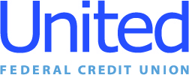

**United Federal Credit Union – Press Release**

March 06, 2025

Contact: Diana Wake

Phone: (269) 294-0163

Email: [dwake@UnitedFCU.com](mailto:dwake@UnitedFCU.com)

United Federal Credit Union, 150 Hilltop Road, St. Joseph, Michigan, 49085

**United Federal Credit Union Names Josh Munoz   
Mortgage Advisor in Fort Smith**

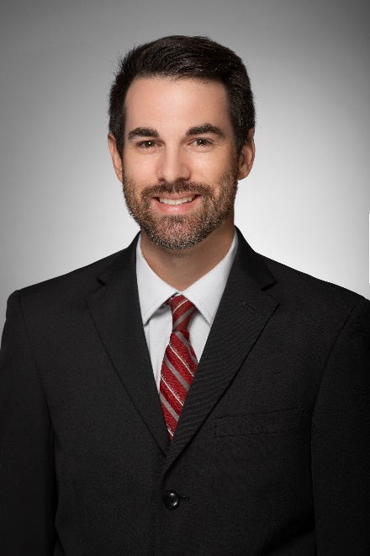

*Josh Munoz, Mortgage Advisor in Fort Smith, Arkansas*

**FORT SMITH, Ark. –** United Federal Credit Union (United) has appointed Josh Munoz to the position of Mortgage Advisor at its branch at 5800 Rogers Ave. in Fort Smith.

In his role, Munoz will generate product awareness to credit union members regarding their real estate financing needs and generate investment quality mortgage loans. He will use his knowledge in the industry to provide a quality real estate lending experience through personal financial counseling.

Munoz has 14 years of mortgage lending and banking experience. He spent seven years at United as Mortgage Advisor and Mortgage Loan Processor before moving to a role as a Mortgage Loan Officer with a bank in Fort Smith.

In the community, he helps United with its efforts supporting the Boys and Girls Club of Fort Smith, the American Red Cross, and the United Way of Fort Smith Area. He also supports the Fort Smith Chamber of Commerce and the Greater Fort Smith Association of Homebuilders.

**____________**

**About United**

United Federal Credit Union has served its Members since 1949 by helping them to build a sound financial future. United consists of more than 194,000 Member/owners worldwide and manages assets in excess of $4 billion. Its corporate office and main branch are in St. Joseph, Mich., with additional branches in Arkansas, Indiana, Michigan, Nevada, North Carolina, Ohio, and Pennsylvania. Federally insured by NCUA. Equal opportunity lender. Equal housing lender. For more information visit [UnitedFCU.com](http://www.unitedfcu.com)

# # #