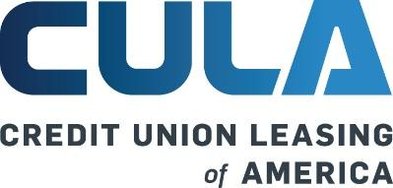

**CULA Grows by Double Digits in 2024, Saves Credit Union Members ~$63M Annually with Vehicle Leases**

*CULA credit union partner members’ monthly vehicle lease payments averaged $159 less vs traditional auto loan payments; CULA grew credit union dealer partners year over year and expanded to 27 states, as vehicle leasing grew to nearly 25% of all auto financing nationally*

**San Diego, CA – April 10, 2025** – Credit Union Leasing of America (CULA) delivered strong growth in 2024, with double-digit increases in credit union and dealer partnerships as an increasing number of credit unions leveraged CULA’s indirect vehicle leasing program. CULA partner credit union members saved a total of more than $63 million on lease payments in 2024, and an average of $159[1] per month versus traditional auto loan payments.

Expanding its presence to 27 states in 2024, CULA added four new states—Oregon, Maine, Idaho, and Vermont—further strengthening its national footprint. The Company also increased its active dealer partners by 91% in 2024 compared to 2023. Today, CULA has over 2,554 total dealer partners signed to its program.

As affordability remains a major challenge in the auto market, more consumers are choosing leasing versus traditional auto loans, given leasing’s dramatic savings. In 2024, vehicle leasing rose to 24.5% of new auto sales nationally, from 22.6% in 2023 and 17.2% in 2022, according to *Experian’s State of the Automotive Market Q4 2024 Report.*

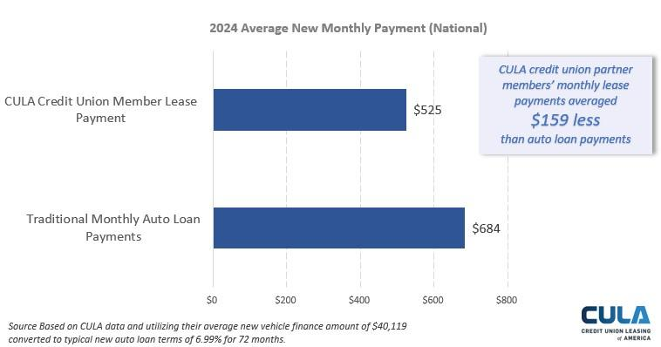

In addition to enabling savings for its partner credit unions’ members, CULA data revealed that those credit unions using its program in 2024, compared to credit unions not partnered with CULA, realized higher loan yield (25 bps higher), greater auto loan growth (2.21% vs -3.62%) and higher member growth (3.96% vs 3.36%).

"With financial pressures and inflation concerns continuing to impact auto shoppers, CULA’s credit union partners have been able to save their members significant amounts on transactions in 2024, compared to traditional auto loans; they do this by offering competitive rates through our leasing solution. It is also gratifying to see that loan yield, member growth and auto loan growth is higher for our partner credit unions than for those who are not offering our leasing program," said Ken Sopp, President of CULA.

“Member savings, vehicle leasing’s continued growth, and positive impacts on our partner credit union’s businesses affirm that CULA’s data-driven and innovative program is well-positioned to continue driving credit union adoption and to deliver another strong year in 2025,” continued Sopp.

Experian’s *State of the Automotive Market Q4 2024* Report also reveals that leasing rates are rising across most vehicle makes and is dominating in key markets including Michigan, New Jersey, and New York, highlighting its growing appeal. Additionally, lease terms and payments are decreasing across all risk segments, further enhancing affordability and accessibility for a wider range of buyers. These factors reinforce leasing as a compelling alternative to traditional financing and CULA’s appeal to a growing number of credit unions.

"The recently announced tariffs will likely drive auto prices even higher, outpacing inflation and putting even more pressure on American consumers' budgets," said Sopp. "Even before these tariffs, our partners have observed the average auto transaction price climb from $36,755 in 2022 to $40,912 in 2024, reflecting the broader rise in vehicle costs. With this backdrop, credit unions have a clear opportunity to provide even more cost-effective solutions for their members through CULA."

“Partnering with CULA for our leasing services has been a major benefit for both our credit union and our members,” said Dort Financial Credit Union CLO Sharon Lobo. “With this partnership, we have diversified our portfolio and increased yields while providing our members with flexible and affordable auto finance options. CULA helps us to provide an even greater value to our members.”

For over 35 years, CULA has been the leader in indirect vehicle leasing for credit unions, offering an analytically driven, high-value program that simplifies the complexities of leasing—including insurance, operations, compliance, and more. With a deep understanding of the credit union financial model, CULA has built long-term partnerships with top-tier credit unions, including nine of the top 10 credit unions offering leasing in the U.S. Its program enables credit unions to seamlessly integrate leasing into their portfolios while providing dealers with a valuable financing option—especially as affordability remains a top concern for consumers.

**About Credit Union Leasing of America**

Credit Union Leasing of America (CULA) has been the leader in indirect vehicle leasing for credit unions for over 35 years. Founded in 1988, CULA provides best-in-class program assistance, analytics reporting, compliance support, dealer management tools and member services. The CULA indirect vehicle leasing program empowers credit union innovators to diversify their existing loan portfolios, improve yield and expand member services. Visit <https://www.cula.com/> to learn more.

**Media contacts:**

Angela Jacobson, mWEBB Communications, angela@mwebbcom.com, (714) 454-8776

Melanie Webber, mWEBB Communications, melanie@mwebbcom.com, (949) 307-1723

1. Based on CULA data and utilizing their average new vehicle finance amount of $40,119 converted to typical new auto loan terms of 6.99% for 72 months.