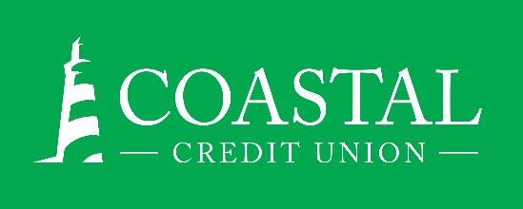**NEWS RELEASE**

Contact: Joe Mecca

VP, Communication / Spokesperson

919-420-8044 /jmecca@coastal24.com

**FINAL: For Immediate Release**

**Coastal Credit Union Hires Anita Marshall to Lead Rocky Mount Branch**

**RALEIGH, N.C. (May 6, 2025) –** [Coastal Credit Union](https://www.coastal24.com/) has hired Anita Marshall as Branch Manager of its location at 1080 N. Winstead Ave in Rocky Mount.

In her role, she will be responsible for delivering exceptional member service, relationship management, and community involvement. She will lead the branch team toward achieving the credit union’s goals around membership, loan, and deposit growth.

Marshall brings 20 years of financial services experience to Coastal, including several roles in branch management, sales, and market leadership. She was most recently a Financial Sales Manager for a large regional bank and has past credit union experience at State Employees Credit Union of Maryland. She holds a business degree from the University of Maryland Global Campus.

**About Coastal Credit Union**

Coastal Credit Union is a not-for-profit, member-owned, financial cooperative, offering a full range of financial products and services. Coastal was chartered on August 31, 1967, with the mission of fostering the credit union philosophy of “people helping people.”  Today, with $5.72 billion in assets, Coastal serves 339,000 members from 1,800 business partners and is among the leading financial institutions in North Carolina. Coastal operates 23 locations in central North Carolina and serves members in all 50 states through a network of 5,600 shared branches, 30,000 surcharge-free ATMs, mobile banking featuring mobile check deposit, and a robust offering of online services at [www.COASTAL24.com](http://www.coastal24.com/). For more Coastal news, visit our [online newsroom](https://www.coastal24.com/about/about-coastal/pressroom).

**###**