 | 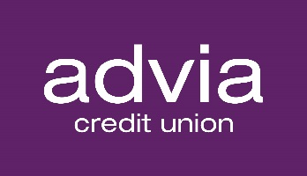 |  |  | Contact:  Nancy Loftis, VP of Marketing & PR  6400 West Main| Kalamazoo, MI 49009  844-238-4228 x1142 | www.adviacu.org  For Immediate Release – May 6, 2025
New Associate Board Member and Audit Committee Members to Join Advia Credit Union’s Dedicated Volunteers

Advia Credit Union is proud of the strong network of dedicated volunteers that make up its Board of Directors and special committees. Recently, three (3) new individuals were added as volunteers within Advia’s growing regions throughout Michigan, Illinois, and Wisconsin.

 | Darren Fago, CFA was named a Board Audit Committee Member for Advia. Fago lives in Lemont, Illinois, and works as Director of Advisory Services with ALM First Financial Advisors. He previously worked as VP of Investment Advisory Services with  Balance Sheet Solutions, LLC, along with Alloya CFCU and CUNA Mutual Group. “Helping credit unions is even more fulfilling when it’s my own credit union where I am a member,” mentioned Fago, regarding his membership with Advia. Fago holds a CFA designation from the CFA Institute, an MBA with a concentration in Finance from Edgewood University and holds a BS in Psychology from Illinois State University.

Dr. Brittani Shantel Jackson was recently named a Board Audit Committee Member for Advia. Jackson lives in Portage, Michigan, works as an Assistant Professor of Accountancy at Western Michigan University, is a Certified Public Accountant, and has prior experience working with diverse industries as an Audit Experienced Associate for Private Company Services with PwC Detroit. “I am eager to serve as a volunteer on Advia’s Audit Committee because I strongly align with Advia’s mission of providing financial advantages and fostering economic empowerment within the communities it serves,” said Jackson. In addition to her CPA, Jackson holds a Ph.D. in Accounting from Indiana University, a Master of Science in Accounting from Wayne State University, and a BA in Accounting from Michigan State University. |  | 
 | Aimee Jachym was recently named an Associate Board Director for Advia. Jachym lives in the Kalamazoo, Michigan area and is a partner at the law firm of Miller, Johnson, Snell & Cummiskey, P.L.C. “I am impressed with Advia’s presence in the community, along with its growth into the midwestern markets. The Credit Union’s values align with mine, and I am passionate about using my time and talents to further the missions of values-aligned nonprofit organizations in the community,” stated Jachym. Previously a Commercial Contracts Manager with Parker Hannifin, Jachym is also co-founder and prior President of Korean Kids and Orphanage Outreach Mission in South Korea. Jachym holds a Juris Doctorate, Cum Laude, from Wayne State University Law School and BBA from Western Michigan University.

Advia Credit Union is governed by a volunteer group of Board of Directors who represent the many facets of the communities where Advia operates. These individuals dedicate countless hours to overseeing the operational soundness of the Credit Union. Of note, Advia is positioned within the top 3% of credit unions nationally when measured by total assets.

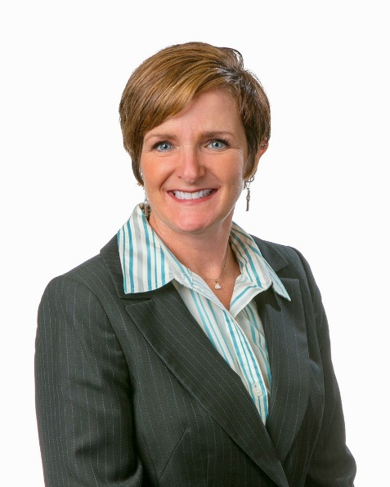 | “We are thrilled to name these three incredibly well accomplished individuals to our volunteer Board and Audit Committee. The wealth of experience they bring along with their commitment to furthering our not-for-profit financial cooperative business model into the communities Advia serves will continue to position us as a thriving credit union within the Midwest,” stated Donna Kalmeta, Advia’s volunteer Board Chair.

About Advia Credit Union - Advia Credit Union’s mission is to provide financial advantages to its members. With $3.5 billion in assets, Advia seeks to provide quick and easy access to money and time-saving financial tools to 200,000 members in Michigan, Wisconsin, and Illinois. Advia’s team of nearly 600 professionals delivers excellent service and innovative products at 34 locations and via digital and mobile platforms. Advia is guided by its core values: driving progress, acting with integrity, building and strengthening relationships, and keeping people at the core. Visit www.adviacu.org to learn more about how we provide Real Advantages for Real People™.

6400 West Main; Kalamazoo, MI 49009 | www.adviacu.org

