***FOR IMMEDIATE RELEASE***

*CONTACT:*

*Julie Woloszyn, PCM*

*Marketing Manager*

*Corporate Central Credit Union*

*(414) 425-5555*

**Corporate Central Holds 44th Annual Meeting and Announces Board of Directors**

**MILWAUKEE, WI – May 13, 2025** – Corporate Central held its 44th Annual Meeting on Thursday, May 8, at the Kalahari Convention Center in Wisconsin Dells, WI, in conjunction with The Wisconsin Credit Union League’s Annual Convention & Exposition. The event brought together member credit union leaders from across the region, both in person and via a live stream on YouTube, to reflect on the past year and look toward the future of the credit union movement.

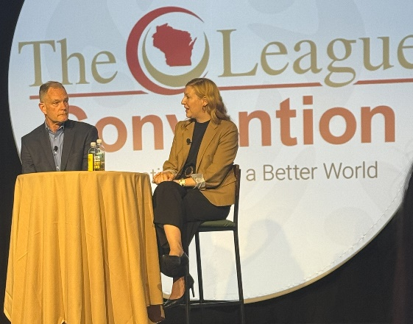During the meeting, Corporate Central President/CEO Chris Felton and The Wisconsin Credit Union League President/CEO Sarah Wainscott led a collaborative discussion on the state of the industry, addressing key strategic initiatives, opportunities, and challenges. This open dialogue reinforced Corporate Central’s commitment to the core values of partnership and collaboration that define the credit union industry.

Corporate Central also announced its 2025–2026 board of directors and executive committee:

Corporate Central President/CEO Chris Felton and The Wisconsin Credit Union League President/CEO Sarah Wainscott discuss the state of the credit union industry.

**Executive Committee:**

* **Chair:** Val Mindak, Park City Credit Union
* **Vice Chair:** Sue Johnson, Fort Community Credit Union
* **Secretary:** Steve Koenen, Altra Federal Credit Union
* **Treasurer:** Chris Allen, Fox Communities Credit Union

**Board of Directors:**

* Laurie Butz, Capital Credit Union
* Angela Hanson, Heartland Credit Union
* Daniel Ige, “Golden Rule” Community Credit Union
* Jay Magulski, Landmark Credit Union
* Charlie Zanayed, CoVantage Credit Union

For more information about Corporate Central and its commitment to advancing the credit union movement, [visit corpcu.com](https://corpcu.com/?utm_source=callahan&utm_medium=press_release&utm_campaign=202505_annual_meeting).

**Helping Members to be *Wildly* Successful**

**About Corporate Central Credit Union**

*Corporate Central Credit Union is a federally insured financial cooperative built on the values of commitment to service, fiscal responsibility, and respect for the individual. We cultivate a culture of respect, ethics, teamwork, and innovation. We are "Helping Members to be Wildly Successful" by delivering industry knowledge and expertise to help credit unions achieve their strategic objectives and compete in today’s evolving financial services industry. We are motivated to passionately serve our members and strive to learn, create, and innovate daily. Please visit* [*corpcu.com*](https://nam04.safelinks.protection.outlook.com/?url=https%3A%2F%2Fwww.corpcu.com%2F&data=02%7C01%7Corianna.valentine%40corpcu.com%7Cdd0891906c18446a015a08d7f84333c2%7C8c98155452aa4e2fb39e7bf6d1dcbc82%7C0%7C0%7C637250839841454875&sdata=h4H9rneW%2Fp%2FHCqtiHVVvRNCMexK8L36Xa%2BXA3AYy3%2F4%3D&reserved=0) *to learn more, and follow us on* [*LinkedIn*](https://nam04.safelinks.protection.outlook.com/?url=https%3A%2F%2Fwww.linkedin.com%2Fcompany%2Fcorporate-central-credit-union%2F&data=02%7C01%7Corianna.valentine%40corpcu.com%7Cdd0891906c18446a015a08d7f84333c2%7C8c98155452aa4e2fb39e7bf6d1dcbc82%7C0%7C0%7C637250839841464869&sdata=w5o39K1HeFxH0NQhLZmtwUnPbHxYlxzmaKAV%2FPvGxfQ%3D&reserved=0)*,* [*Facebook*](https://nam04.safelinks.protection.outlook.com/?url=https%3A%2F%2Fwww.facebook.com%2FCorporateCentral%2F&data=02%7C01%7Corianna.valentine%40corpcu.com%7Cdd0891906c18446a015a08d7f84333c2%7C8c98155452aa4e2fb39e7bf6d1dcbc82%7C0%7C0%7C637250839841464869&sdata=mpvyG181XHXQqKJCz0398jN2J4SfqkPN4fenQQ3FM3c%3D&reserved=0)*,* [*Twitter*](https://nam04.safelinks.protection.outlook.com/?url=https%3A%2F%2Ftwitter.com%2FCorpCU&data=02%7C01%7Corianna.valentine%40corpcu.com%7Cdd0891906c18446a015a08d7f84333c2%7C8c98155452aa4e2fb39e7bf6d1dcbc82%7C0%7C0%7C637250839841474863&sdata=%2Blyy6biIsQS7DfDqUuFQf58tKS43XeyHj8YBZn5qSmg%3D&reserved=0)*, and* [*YouTube*](https://nam04.safelinks.protection.outlook.com/?url=https%3A%2F%2Fwww.youtube.com%2Fchannel%2FUCLt6UMRaRkpGF-qWWx8T94w%3F&data=02%7C01%7Corianna.valentine%40corpcu.com%7Cdd0891906c18446a015a08d7f84333c2%7C8c98155452aa4e2fb39e7bf6d1dcbc82%7C0%7C0%7C637250839841474863&sdata=D%2FOF21jJX8wIQX4PQJiciJ10zNiGKNbmLTGBme%2FwWeM%3D&reserved=0)*.*