

**PRESS RELEASE**

**FOR IMMEDIATE RELEASE**

### Contact: June 24, 2025

### Carla Keister

### 866-56-TOWER, ext. 7144

### carla.keister@towerfcu.org

**42nd Annual Tower Classic Charity Golf Tournament Raises $72,420 for the Johns Hopkins Children’s Center—Bringing Total Donated to Helping Children in Need to Over $1.1 Million!**

*Hosted by the TowerCares Foundation, Tower Classic raised the highest amount in the event’s 42-year history, with all proceeds going to help critically ill children receiving care at Johns Hopkins Children’s Center in Baltimore, Maryland. Over the years, the annual golf tournament has raised over $1.1 million to help local children in need.*

[**June 24, 2025 - Laurel, MD**] Emerson “Emme” and Elle Thomas were born at just 25 weeks gestation at the Johns Hopkins Children’s Center (JHCC) in Baltimore, Maryland, a local Children’s Miracle Network hospital. Both girls were born with brain bleeds, and while Elle’s condition healed on its own, Emme required multiple brain surgeries before the age of six. She was also diagnosed with epilepsy and cerebral palsy.

Today, thanks in part to the incredible care she has received at JHCC, Emme is thriving, getting high math scores, playing games, and doing all the things a child her age should be doing. Elle, who also had to overcome adversity early on, continues to thrive as well.

**We do it for the children. Children like Emme and Elle.**

Now in its 42nd year, the Tower Classic Charity Golf Tournament raises funds annually to help the thousands of critically ill children like Emme and Elle who are receiving care at JHCC and their families.

The tournament, held June 6 at Renditions Golf Course in Davidsonville, Maryland, and hosted by the TowerCares Foundation, raised an all-time high of $72,420—pushing the total donated over the years to over $1.1 million. Emme and Elle’s father, Kevin Thomas, was an honored guest at the tournament, and shared the girls’ inspiring journey.

“This year’s Tower Classic was one for the record books!” said Rick Stafford, President of the TowerCares Foundation. “We were honored to have Kevin Thomas share his family’s story and talk about the amazing care his daughters have received over the years at the Children’s Center. Together, we’ve now raised over a million dollars to help critically ill children and their families get the care and support they need. We couldn’t have achieved this milestone without the generosity of our tournament sponsors including Tower Federal Credit Union and Allied Solutions, and all of our golfers, valued partners, and event volunteers. We are proud to support JHCC and the remarkable work they do every day to help kids like Emme and Elle.”

To learn more about the TowerCares mission and the organizations we support, visit [towercaresfoundation.org](https://www.towercaresfoundation.org).

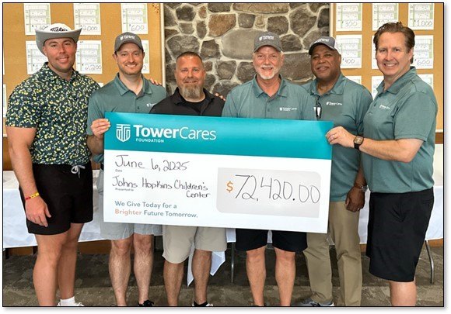

**PHOTO CAPTION:** The 2025 Tower Classic Charity Golf Tournament, hosted annually by the [TowerCares Foundation](https://www.towercaresfoundation.org), raised $72,420 for the Johns Hopkins Children’s Center (JHCC) in Baltimore, Maryland. This the highest amount raised in the tournament’s 42-year history—bringing the total donated to help critically ill children through the years to over $1.1 million! The Tower Classic was held June 6 at Renditions Golf Course in Davidsonville, Maryland, with 135 golfers and over 35 sponsors, including tournament sponsors Tower Federal Credit Union and Allied Solutions. Kevin Thomas, whose twin daughters Elle and Emme were born at just 25 weeks gestation at JHCC and have received extensive care there through the years, was a special guest at the tournament and shared the girls’ inspiring journey. Pictured with Thomas (middle left) are TowerCares Board members (left-right) Brian Barrentine, Director; Tom Poe, Treasurer; Allen Brisentine III, Chairman; Al Smith, Secretary; and Rick Stafford, President. [Photo Credit: TowerCares Foundation]

**About TowerCares Foundation**

Headquartered in Laurel, Md., the mission of the [TowerCares Foundation](https://www.towercaresfoundation.org) is to support children in need as well as brave and heroic individuals who have sacrificed while protecting our freedom. TowerCares creates programs and supports well-vetted charities that are in alignment with our mission. Since our inception in 2015, the TowerCares Foundation has provided over $3 million in grants, donations and scholarships. The TowerCares Foundation is a 501(c)(3) charitable organization, and a participating charity in the Combined Federal Campaign (#23594) and Maryland Charitable Campaign (#47-4164006). Donations are tax-deductible. We are a platinum-level GuideStar participant, demonstrating our commitment to transparency. For more information about TowerCares, visit towercaresfoundation.org.