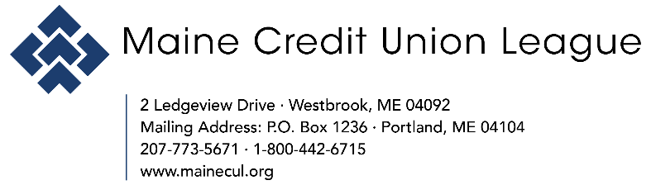

FOR IMMEDIATE RELEASE
July 22, 2025

Media Contact:
Jen Burke, VP – Outreach & Strategic Initiatives
207-773-5671, ext. 295
jburke@mainecul.org

Maine Credit Union League Welcomes New Director of Advocacy and Compliance
Jared Gay selected to fill critical governmental affairs role
(WESTBROOK, ME) – The Maine Credit Union League is pleased to announce the hiring of Jared Gay as its new Director of Advocacy and Compliance. A seasoned public policy and legislative professional, Gay brings a wealth of experience in governmental affairs, advocacy leadership, and community engagement to the credit union movement.
In his new role, Gay will lead the League’s governmental affairs strategy, spearheading legislative and regulatory advocacy efforts on behalf of Maine’s credit unions. He will work closely with state and federal policymakers, credit union stakeholders, and League leadership to promote and protect the interests of credit union members across the state. Gay also will manage compliance initiatives and PAC activities.
“We are thrilled to welcome Jared to the Maine Credit Union League,” shared Elise M. Baldacci, President of the Maine Credit Union League. “His extensive background in legislative strategy, advocacy, and public service make him an ideal fit for this role, and we are confident his leadership will strengthen our collective voice in Augusta and Washington, DC.”
Prior to joining the League, Gay served as Director of Public Policy & Advocacy at United Way of Southern Maine, where he made an immediate and lasting impact. During his tenure, he authored and introduced the organization’s first-ever legislation—a housing diversion bill—setting a precedent in United Way's policy efforts. He also led comprehensive community advocacy campaigns, forged strategic partnerships, and shaped legislative agendas to advance equity and opportunity for Maine residents.
Earlier in his career, Gay worked as a Legislative Aide in the Maine Senate Majority Office, supporting the Senate Majority Leader and other lawmakers on communications, legislative planning, and constituent services.
“It’s an honor to step into this role and support the mission of Maine’s credit unions,” shared Gay. “I’m excited to lead advocacy and compliance efforts at the state and federal levels, and to work with policymakers and partners to advance priorities that reflect the values of the credit union movement.”
A resident of Westbrook, Gay is a graduate of the University of Maine where he earned a Bachelor of Arts in Political Science. In his free time, he enjoys skiing, playing pickleball, and following all things Boston sports.

###

About the Maine Credit Union League

The Maine Credit Union League is a nonprofit, professional trade association that exists to serve Maine’s credit unions. Founded in 1938, the League’s mission is to help credit unions succeed and improve the financial lives of their members. As the trade association for Maine’s credit unions, the League provides advocacy, education, and other resources designed to assist credit unions in meeting the needs of their membership. For more information, visit www.mainecul.org.

