FOR IMMEDIATE RELEASE

CONTACT:
Jesse Kohl, President
InterLutions, LLC
(414) 433-0174

InterLutions and Acumen Financial Advantage Collaborate to Deliver Consultative Executive Benefit Services for Credit Unions

MILWAUKEE, WI – July 10, 2025 – InterLutions, an innovative CUSO committed to enhancing employee benefits across the credit union industry, is proud to announce a strategic partnership with Acumen Financial Advantage (AFA). This collaboration introduces a suite of Executive Benefit Consulting Services designed to help credit unions strengthen leadership retention, improve investment performance, and expand their charitable reach.

“Credit unions are seeking smarter ways to invest in their people while enhancing their mission-driven impact,” said Jesse Kohl, President. “By partnering with Acumen Financial Advantage, we’re empowering our industry to proactively address executive retention, benefits prefunding, and charitable giving—all while maintaining financial soundness.”

The new partnership stems from insights gathered through group forums, client feedback, and direct outreach with credit union leaders. InterLutions identified three critical areas where credit unions need a trusted and consultative partner:

- Executive Retention – a vital strategy to ensure consistent leadership, strengthen institutional knowledge, and drive mission-aligned growth in a competitive talent landscape.
- Benefits Prefunding – a calculated approach to reduce long-term costs while enhancing the ability to attract and retain talent through robust benefit structures.
- Charitable Donation Accounts (CDAs) – innovative concepts to further support our communities by boosting charitable contributions while maintaining regulatory compliance.

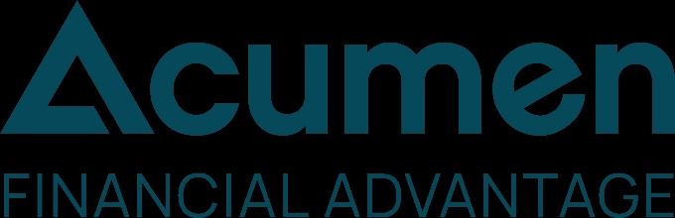
Headquartered in La Jolla, California, AFA consults with more than 100 credit unions nationwide. They specialize in executive compensation and benefit programs, custom-designed to help recruit, reward, and retain leadership talent. AFA’s disciplined focus on safety, compliance, and strategic planning ensures long-term success for the credit unions they serve.

“This partnership allows us to align our deep consulting expertise with InterLutions’ strong presence in employee benefits,” said Ryan Millman, Principal and Co-founder of AFA. “Together, we’ll help credit unions become even more competitive in today’s talent-driven economy.”

“This is not just about expanding services—it’s about deepening the impact we have on our credit union clients,” said Kohl. “Whether it’s retaining top talent or maximizing philanthropic efforts, our solutions are designed to move credit unions forward.”

To kick off the partnership, InterLutions and AFA will be hosting a series of complementary webinars focused on helping credit unions learn how to strengthen their leadership retention while improving their bottom line. To learn more and to register for the first webinar, A Consultative Approach to Executive Benefits, on July 30, 2025 at 2:00 p.m. CT, please visit InterLutions’ website.

About InterLutions
InterLutions is the industry’s premier Employee Benefits CUSO delivering innovative and collaborative health plans for large and small credit unions. We leverage claims data, HR technology, and pooled plans to deliver lower cost health plans with superior coverage and enhanced plan designs.

Insuring over 10,000 lives with credit union clients ranging from 1 employee to 1,000+ employees across the country, we utilize our purchasing power along with the collaborative spirit of the credit union industry to deliver enhanced benefits at lower costs. Employees are the greatest asset to our industry and deserve the very best benefits. Home | InterLutions (interlutionscuso.com)

About Acumen Financial Advantage
Acumen Financial Advantage is the financial performance partner of choice for forward-thinking credit unions, delivering bespoke talent retention, investment, and charitable impact solutions that consistently outperform industry benchmarks. Acumen’s unrivaled expertise in insurance and financial solutions means we provide solutions that are not only cost-effective and flexible but also uniquely designed to foster long-term growth and leadership in the credit union space. With a deep understanding of NCUA regulations and an unwavering commitment to client service, we ensure each strategy is customized to maximize impact and value. Find out more at www.acumenfa.com

