**TDFCU Welcomes New Chief Operating Officer: A Proven Leader in Member Experience and Operational Excellence**

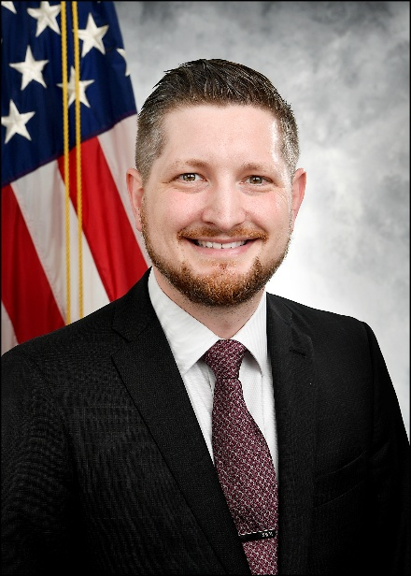

**Washington, D.C.** — **July 21, 2025** —Treasury Department Federal Credit Union (TDFCU), proudly serving its members since 1935, is excited to welcome **Nicholas Moreland** as its new **Chief Operating Officer (COO)**.

A proud graduate of Towson University with a Bachelor's degree in Business Administration and an MBA from Southeastern Oklahoma State University, Moreland combines academic insight with over a decade of real-world leadership experience, helping teams thrive, strengthening member relationships, and building operations that work for both staff and the communities we serve. His passion for building strong teams, improving operational systems, and creating memorable member experiences makes him a perfect fit for TDFCU's next chapter.

Throughout his career, Moreland has earned a reputation for delivering results while inspiring those around him. In his previous role as VP of Member Experience & Retail Banking at Signal Financial FCU, Moreland oversaw a wide range of departments, including branches, digital member services, and business development. He's known for turning big ideas into tangible results— by driving deeper member focused conversations, introducing user-friendly digital tools, and building innovative, compliant banking solutions for today's evolving marketplace.

I am honored to join TDFCU and a team so deeply committed to its members. I look forward to building on that passion as we work together to create meaningful experiences and lasting value for every member we have the pleasure to serve!

Moreland also has deep roots in coaching, development, and culture-building. From building high-performing teams to enhancing member engagement and streamlining services, his work demonstrates an evident passion for service, strategy, and people. His leadership at PNC Bank earned him multiple recognitions for driving performance and making workplaces more connected and empowered.

Treasury Department Federal Credit Union President & CEO, Lee Woolley, said, "The team at TDFCU is super excited for Nick to join our ranks!  He brings deep professional experience and a passion for serving others that is palpable to everyone he meets!"

TDFCU is thrilled to welcome Moreland to the executive team and looks forward to the energy, expertise, and vision he brings as we continue our mission to serve our members with excellence.

**About TDFCU**

Chartered in 1935 by employees of the Treasury Department. The Treasury Department FCU is owned and operated by members who share a common bond through employer or geographic affiliation and governed by volunteers who members elect to serve on the board.

TDFCU is a financial institution dedicated to enhancing the quality of life for its members by providing affordable, personalized, and innovative financial products and services. In turn, any profit the institution makes is returned to the members in the form of better rates, reduced fees, and improved services. TDFCU is where you and your family belong.

Our credit union not only encompasses federal employees but also individuals who live, work, worship, or attend school in the 313 census tracts inside the Capital Beltway, extending north to south from Germantown, MD to Westmoreland State Park, VA, and east to west from Patuxent Research Refuge, MD to Stafford, VA are eligible to join.  [**Click here**](https://www.creditunionmatch.com/join-credit-union?cu=treasury-department-federal-credit-union#/) to use CU Join to check eligibility.

Like all federal credit unions, Signal Financial is closely regulated by the National Credit Union Administration (NCUA), with deposits insured by the National Credit Union Share Insurance Fund (NCUSIF) up to $250,000.

**Media Contact:**

Mary Carew

Marketing Specialist

mcarew@tdfcu.org

(202) 819-0116