

**PRESS RELEASE FOR IMMEDIATE RELEASE: July 9, 2025**

**MEDIA CONTACT:**

Carla Keister

Tower Federal Credit Union

301-497-7000, ext. 7144

carla.keister@towerfcu.org

**Tower Federal Credit Union Earns Great Place to Work® Certification—Seven Years in a Row!**

*Tower has received recognition for the seventh consecutive year by the independent analysts at Great Place to Work®, an industry leader on quantifying employee experience. The prestigious award is based entirely on what current employees say about their experience working at Tower.*

[**Laurel, Md. – July 9, 2025**] For the seventh consecutive year, [Tower Federal Credit Union](https://www.towerfcu.org) has been named a “great workplace” by the independent analysts at Great Place to Work® (GPTW).

**This year, 85% of employees said Tower is a great place to work—compared to 57% of employees at a typical U.S.-based company.1**

Rick Stafford, Tower’s President and CEO, credits Tower’s dedicated employee and management team, along with the credit union’s innovative, service-driven and people-oriented culture as the primary reasons behind this impressive recognition.

“We are thrilled to receive recognition as a Great Place To Work for the seventh year in a row, as we make our employee experience a top priority every day,” Stafford says. “This is an important benchmark because GPTW shows us how Tower measures up as a workplace against companies of different sizes, across all industries. We take the results of these surveys seriously, and we always strive to make Tower the place our employees choose to be. We celebrate and thank them for all they do to earn this incredible recognition.”

Tower earned the GPTW credential based on extensive ratings provided by employees who participated in anonymous voluntary surveys about the credit union’s initiatives, leadership, and overall direction. Employees cited a welcoming work atmosphere, good working environment, generous benefits package, and flexible leave policy as some of the reasons why Tower is a great place to work. Employees also gave high marks for the ways Tower contributes to the local community, most notably through the [TowerCares Foundation](https://www.towercaresfoundation.org), the credit union’s philanthropic arm which helps active military, Veterans, and children in need.

“Tower employees have been ardent supporters of the TowerCares Foundation since its inception in 2015,” said Stafford. “Through fundraising events, recommending new charities to support, and sharing the TowerCares mission with our members, their generosity and support continue to be an integral part of the positive impact TowerCares is having in our community. They are the heart and soul of Tower.”

Great Place To Work is the global authority on workplace culture, employee experience, and the leadership behaviors proven to deliver market-leading revenue, employee retention and increased innovation.

"Great Place To Work Certification is a highly coveted achievement that requires consistent and intentional dedication to the overall employee experience," says Sarah Lewis-Kulin, VP of Global Recognition at Great Place To Work. She emphasizes that Certification is the sole official recognition earned by the real-time feedback of employees regarding their company culture. “By successfully earning this recognition, it is evident that Tower stands out as one of the top companies to work for, providing a great workplace environment for its employees."

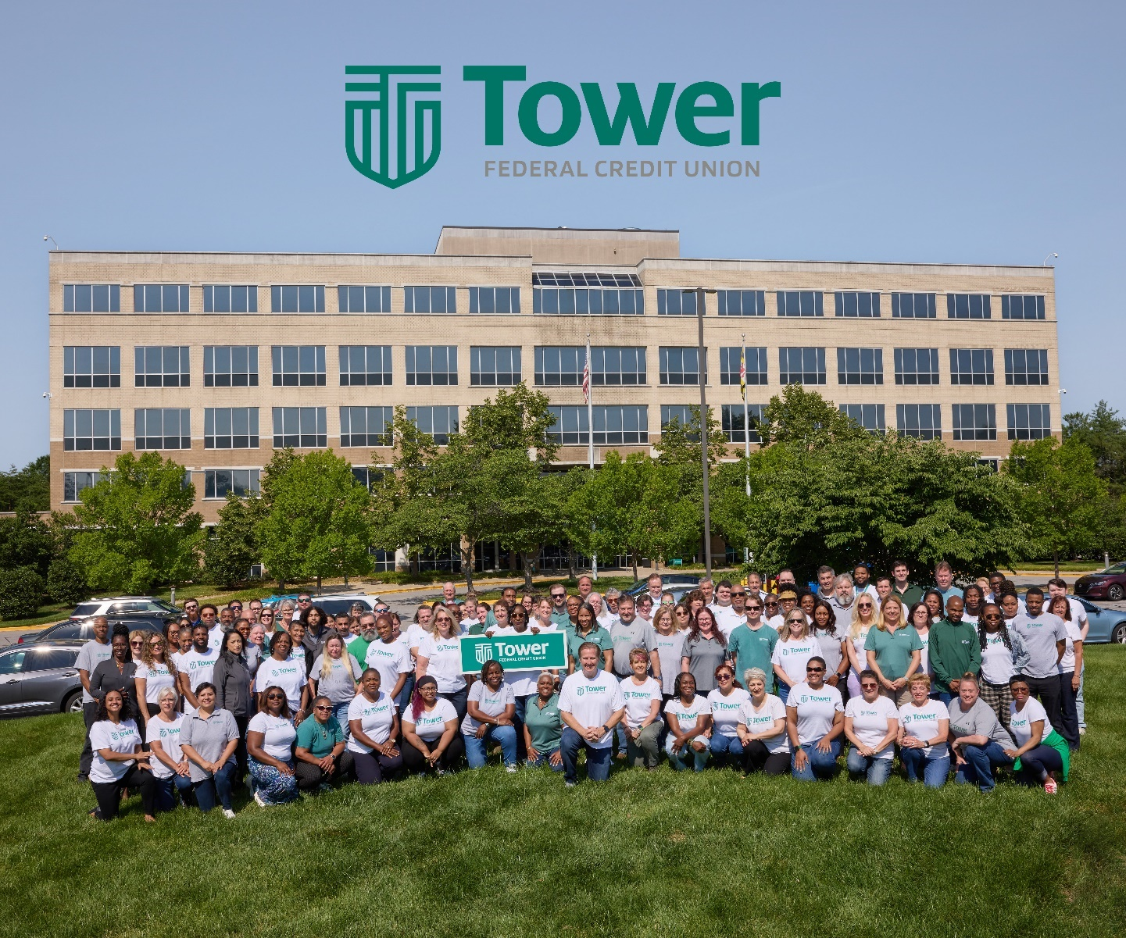

**PHOTO CAPTION:** Tower Federal Credit Union employees gather outside Tower’s Headquarters building located in Laurel, Maryland, to celebrate the credit union’s recognition for the seventh year in a row as a “Great Place to Work” by the independent analysts at Great Place to Work®, an industry leader on quantifying employee experience. The credit union also provided lunch for employees as part of the celebration. To view current job openings at Tower, visit [Careers](https://www.towerfcu.org/about/careers) at towerfcu.org. [Photo Credit: Tracey Brown]

**About Tower Federal Credit Union**

[Tower Federal Credit Union](http://www.towerfcu.org/) is a member-owned, non-profit financial institution with headquarters in Laurel, MD. Established in 1953, Tower is one of the largest credit unions in Maryland with over $4.7 billion in assets. We provide a full array of financial products and services for our more than 221,000 members worldwide. We serve our local area members with 12 branches in Anne Arundel, Baltimore, Howard, and Prince George’s counties and four branches at Fort Meade, as well as online services and digital banking at towerfcu.org.

**About Great Place To Work**®

As the global authority on workplace culture, Great Place To Work® brings 30 years of groundbreaking research and data to help every place become a great place to work for all. Their proprietary platform and For All™ Model helps companies evaluate the experience of every employee, with exemplary workplaces becoming Great Place To Work Certified™ or receiving recognition on a coveted Best Workplaces™ List.

Great Place To Work® Certification™ is the most definitive “employer-of-choice” recognition that companies aspire to achieve. It is the only recognition based entirely on what employees report about their workplace experience – specifically, how consistently they experience a high-trust workplace. Great Place to Work Certification is recognized worldwide by employees and employers alike and is the global benchmark for identifying and recognizing outstanding employee experience. Every year, more than 10,000 companies across 60 countries apply to get Great Place To Work-Certified.

*1 Source: Great Place to Work 2021 U.S. National Employee Engagement Study*