FOR IMMEDIATE RELEASE
Media Contact
Melissa Vidito
Illinois Credit Union System
630-983-3400
melissa.vidito@envisant.com

#ILoveMyCreditUnion Day Unites the Credit Union Movement
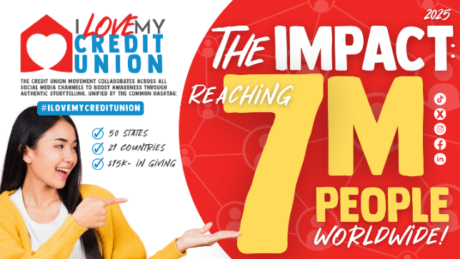
Naperville, IL, August 11, 2025 — Credit unions and their advocates once again united for the annual #ILoveMyCreditUnion Day social media blitz, amplifying the credit union movement. This year’s campaign sparked nearly 25,000 posts—ranging from inspiring stories of community impact to personal reflections on why people cherish credit unions. Together, these voices reached 7 million people, celebrating the spirit and strength of the credit union community.

From industry leaders, like America’s Credit Unions President/CEO Jim Nussle, to front-line tellers the 2025 campaign showcased dedication at every level of the credit union movement. It’s clear that #ILoveMyCreditUnion is growing deep roots as participants across the industry connect to—and own—the message.
Beyond the U.S., global participation boomed with social mentions coming from a record-breaking 21 countries. This expansion marks a step forward in the mission to organically share the credit union message with communities worldwide, raising awareness of the value credit unions bring to their members everywhere.
“The power of this campaign comes from the cooperative spirit that unites our movement,” said Libby Calderone, President/CEO of the Illinois Credit Union League (ICUL). “From CEOs to tellers, from local communities to countries around the world, we showed what’s possible when we collaborate to tell our story. Thank you to every participant for making your voice part of this effort—we are stronger together.”

In addition to the social media success, the 2025 campaign included a charitable giving component that underscored the credit union movement’s mission of “people helping people.” Envisant donated $15,000, divided equally among the three Children’s Miracle Network Hospitals in Illinois. On July 25, ICUL staff and member credit unions presented the checks in person and toured the hospitals, witnessing firsthand the impact of this support.
“The charitable giving component of #ILoveMyCreditUnion Day truly reflects the heart of the credit union movement,” said Staci Hering, Director of Culture and Engagement at ICUL. “Our mission of people helping people comes to life through the spirit of giving, making a real difference in the lives of those we serve.”

This annual event continues to build community pride and highlight the powerful, everyday impact credit unions have on people's lives. Mark your calendars for July 31, 2026, and get ready to join the next #ILoveMyCreditUnion Day celebration.
About the Illinois Credit Union League (ICUL)®
The Illinois Credit Union League is the trade association for 184 state and federal credit unions in Illinois. It focuses on providing legislative and regulatory advocacy, compliance assistance and information, and a wide range of educational and training services to those credit unions, who in turn serve approximately 4 million members. More information can be found at www.icul.com.

###

