FOR IMMEDIATE RELEASE

CONTACT:
Julie Woloszyn, PCM
Marketing Manager
Corporate Central Credit Union
(414) 425-5555

Honoring Heroes: Tunnel to Towers 5K – Milwaukee Doubles in Participation Size, Raises Over $28,000

MILWAUKEE, WI – August 11, 2025 – Corporate Central proudly served as the title sponsor of the second annual Tunnel to Towers 5K Run & Walk – Milwaukee, held Saturday, August 2. The event saw a surge in participation, more than doubling from its inaugural year with 242 runners and walkers—including local first responders, community members, and supporters from across the region—coming together to honor America’s heroes.
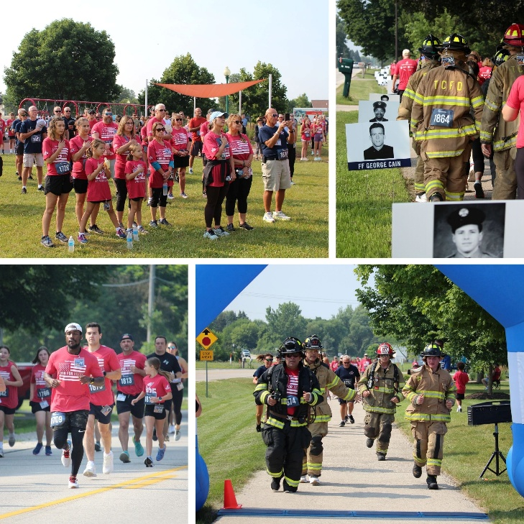

Corporate Central extends heartfelt thanks to the event’s generous sponsors— Fort Community Credit Union, CoVantage Credit Union, Heartland Credit Union, All Star Rentals, Quest Federal Credit Union, Papa Stache, Muskego Dental, Church & Chapel, Matty’s Bar & Grille, Festival Foods, and Guardian Credit Union, whose support played a vital role in the success of this year’s Tunnel to Towers 5K – Milwaukee. Backed by these sponsors and a purpose-driven community, the event raised over $28,000 for the Tunnel to Towers Foundation, including proceeds from a post-race brat fry where participants continued giving back one bite at a time.

The Tunnel to Towers Foundation, inspired by the heroic legacy of New York firefighter Stephen Siller, continues its mission to provide mortgage-free homes to Gold Star and fallen first responder families, build smart homes for catastrophically injured veterans and first responders, and offer financial support to the families of these heroes. Corporate Central is honored to support this cause and help amplify its impact.

“It’s incredible to see how much this event has grown in just one year,” said Chris Felton, President/CEO of Corporate Central. “We’re proud to stand alongside our community and local first responders to support the Tunnel to Towers Foundation. This event is about honoring heroes, and we’re grateful to everyone who came out to make a difference.”

Corporate Central extends heartfelt thanks to all who participated, sponsored, volunteered, and donated. The Tunnel to Towers 5K – Milwaukee is more than a race—it’s a celebration of courage, sacrifice, and community spirit.

Helping Members to be Wildly Successful

About Corporate Central Credit Union
Corporate Central Credit Union is a federally insured financial cooperative built on the values of commitment to service, fiscal responsibility, and respect for the individual. We cultivate a culture of
respect, ethics, teamwork, and innovation. We are "Helping Members to be Wildly Successful" by delivering industry knowledge and expertise to help credit unions achieve their strategic objectives and compete in today’s evolving financial services industry. We are motivated to passionately serve our members and strive to learn, create, and innovate daily. Please visit corpcu.com to learn more, and follow us on LinkedIn, Facebook, Twitter, and YouTube.

